Downloading ES components
To download ES components, you first must download Installation_Area.zip and unpack it in a directory.
You now have a directory with the following files and folder
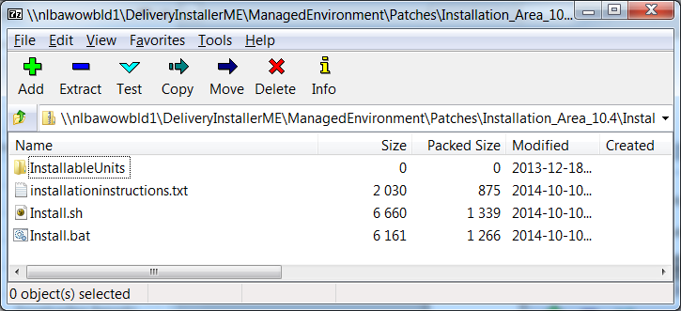

Downloading an Installable Unit
Important: Remove the previous InstallableUnit first from the InstallableUnits folder to prevent wrong files staying behind.

DownLoading Installer
Download Infor_Enterprise_Server_ Installer_<version>.zip and unpack it in the InstallableUnits directory. The Installer is always needed to install an InstallableUnit. You should always use the latest version if you download one of the other InstallableUnits.

DownLoading Tomcat
Download Apache_Tomcat_<version>.zip and unpack it in the InstallableUnits directory. Tomcat is needed for WebUI and C4ws. For LNUI you either need Tomcat or JBoss. You cannot switch during an update from JBoss to Tomcat and vice versa. You should always use the latest version if you download one of these InstallableUnits.

DownLoading JBoss
Download JBoss_<version>.zip and unpack it in the InstallableUnits directory. For LNUI you either need Tomcat or JBoss. You cannot switch during an update from JBoss to Tomcat and vice versa. You should always use the latest version if you download one of these InstallableUnits.

Downloading LNUI
Download Infor_LNUI_<version>_build.zip from Infor Product Download Center for Infor LN (see kb 1834377) and unpack it in the InstallableUnits directory. You need also the latest version of the Installer and either Tomcat or JBoss. You cannot switch during an update from JBoss to Tomcat and vice versa.

Downloading WebUI
Download Infor_WebUI_<version>_build.zip and unpack it in the InstallableUnits directory. Note: WebUI is not supported for LN 10.4 anymore. Updates are available here for LN 10.3.1. To Install Webtop you do need also the latest version of the Installer and Tomcat (e.g. 10.4 or higher). It is recommended to upgrade to LNUI.

Downloading ReportViewer (deprecated)

Downloading C4ws
Download C4WS_<version>.zip and unpack it in the InstallableUnits directory. You need also the latest version of the Installer and Tomcat.

Downloading Lndbc
Download lndbc_<version>.zip and unpack it in the InstallableUnits directory. You need also the latest version of the Installer.

Downloading Infor Integration (only for Windows 2008 R2, 2012 R2) (deprecated)
Download Integration_<version>.zip and unpack it in the InstallableUnits directory. Infor Integration is always needed to install DBConnection.

Downloading DBConnection (only for Windows 2008 R2, 2012 R2) (deprecated)
Download DBConnection_<version>.zip and unpack it in the InstallableUnits directory. You need also the latest version of Infor Integration.

Downloading Ming.le Workspace (deprecated)

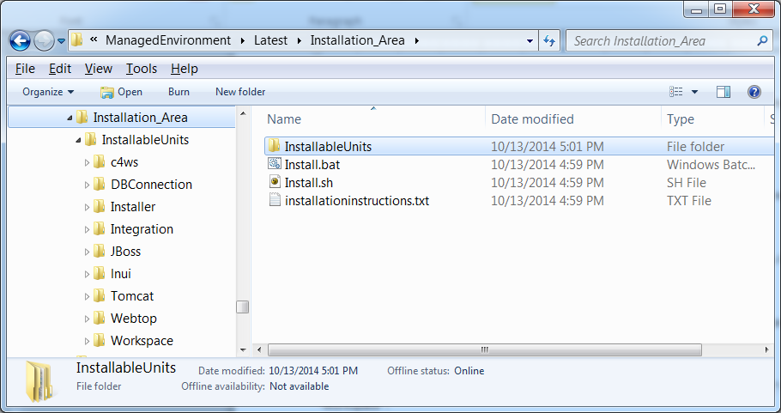Figure 1: The result after downloading all installableUnits.

