Configuration settings for Autoconnect TFS
Step 1: Setting local File Import Folders.
The below screen contains the Local machine locations for File import, Processed Files and Error files.
Inbound:
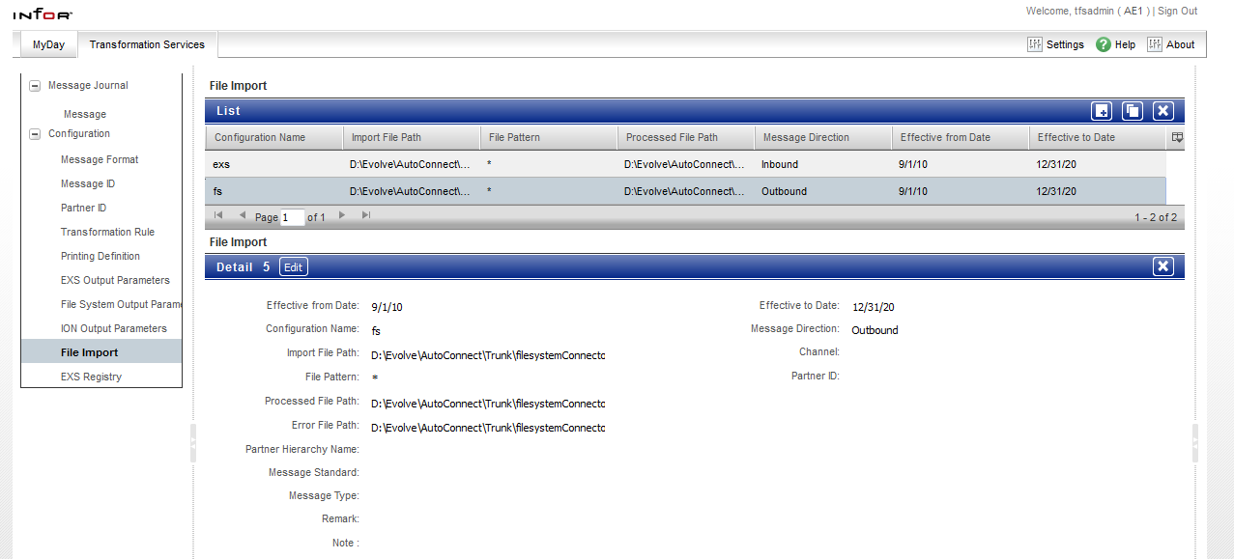
Outbound: 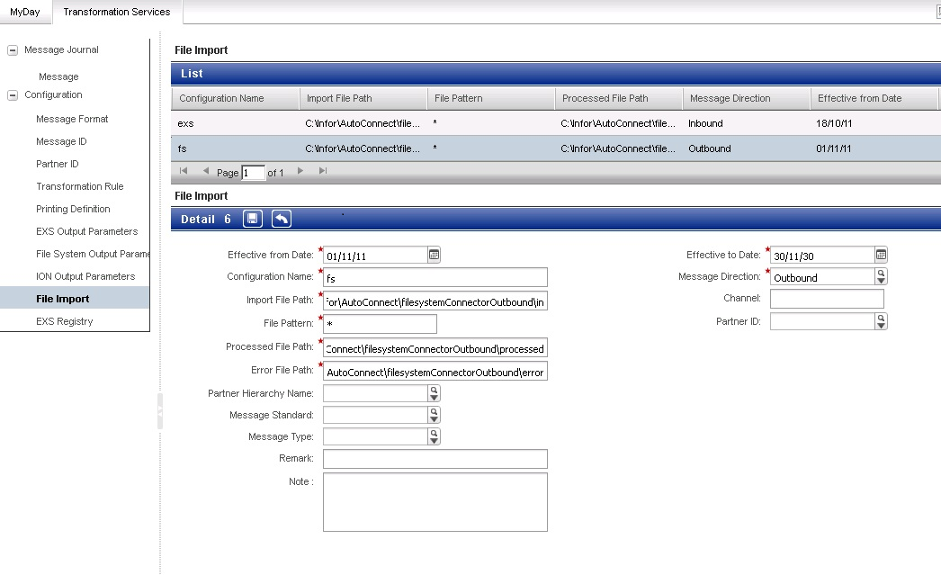Note: Entry for outbound “Configuration Name” should be added to “Autoconnect_Home”\tfs\config\ localContext.xml file.
Step 2: Setting up Message Format.
Each message (EDIFACT/VDA/ANSI X12) contains a unique identifier. (Eg: VDA 4913 has 711). Autoconnect identifies the messages in the “In” folder by the first three characters, which are set in Transformation Services\Message Format screen.
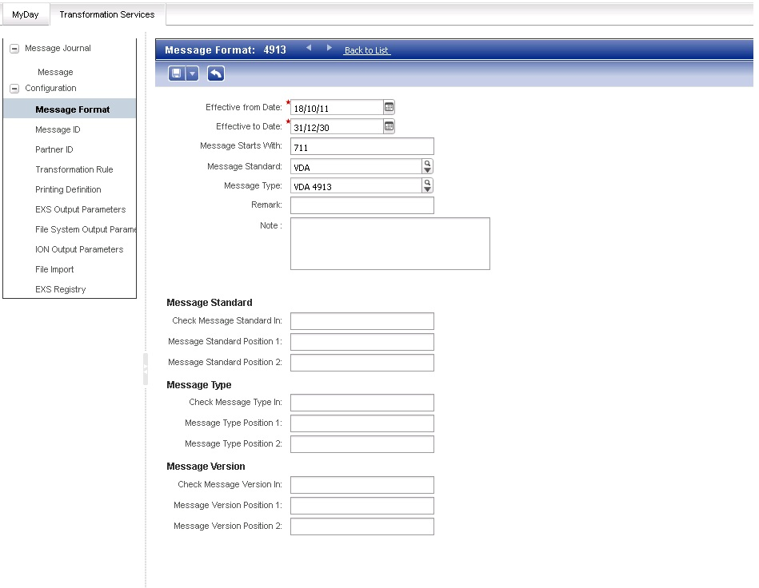

Step 3: Setting up Message ID.
The Message ID contains the identification of sender and receiver IDs of the message by specifying the positions for sender and receiver for a particular Message Format. This is set in Transformation Services\MessageID screen.
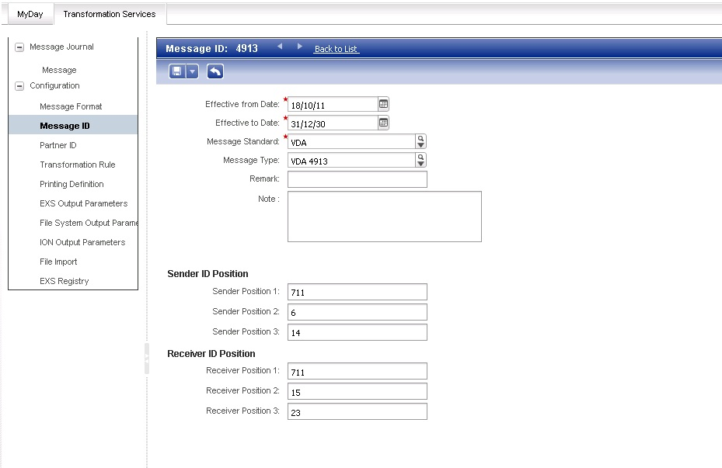

Step 4: Setting up Partner ID.
The Partner ID is set up with specifying the data for the Sender and Receiver IDs. When a message is processed, the sender and receiver IDs are parsed and the matching partner ID is identified. This is set in Transformation Services\Partner ID screen.
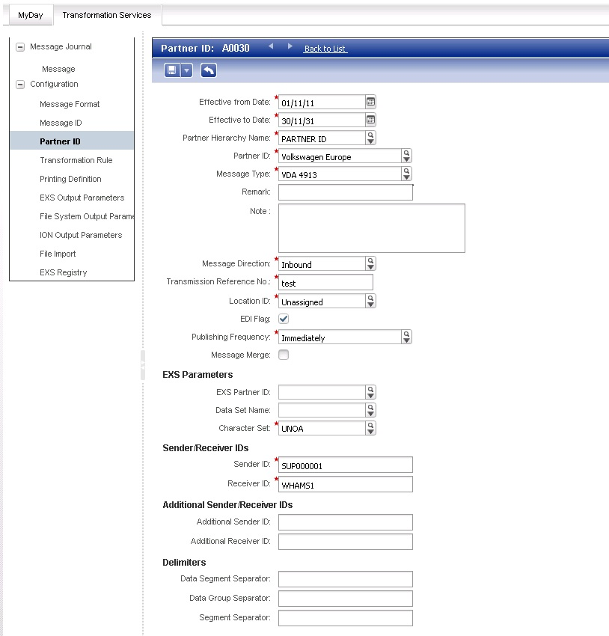

Step 5: Setting up Transformation Rule.
Step 5a: Setting up TFS Configuration.
The XSLT transformation files and other related files are copied to “resources” folder. The location to resources folder is set in %AUTOCONNECT_HOME%/tfs/config/tfs-local.properties file under the below keys:
# Path to customized resources (e.g. style sheets ...)
transformer.resourcePath=D:\\Evolve\\AutoConnect\\Branch-1.0.3/resourcesmod
# Path to trading partner resources (e.g. style sheets ...)
transformer.tradingPartnerPath=D:\\Evolve\\AutoConnect\\Branch-1.0.3/resources/mappings/tradingpartners
# Path to transformation directory (working directory)
transformer.transformPath=D:\\Evolve\\AutoConnect\\Branch-1.0.3/transform

“D:\\Evolve\\AutoConnect\\Branch-1.0.3/” should be replaced with the local Autoconnect installation path.

Step 5b: When any base XSLT files are modified or added
The com.infor.tfs.mappings-1.0.3.jar in location: %AUTOCONNECT_HOME%\Tomcat\webapps\tfs-server\WEB-INF\lib needs to be updated with the new/updated base sheets.
Step 5c: Setting up XSLT file transformations
The %AUTOCONNECT_HOME%/tfs/mdm/mdm.xml contains the configuration for transformation rules. Any new transformation files should be updated in this file to be populated in the “Transformation Rules” screen. The mdm.xml file contains the XSL Transformation file name, the Format file (FFD) name, Inbound or Outbound configuration. The help regarding the different options is given in the mdm.xml file itself.
Sample for configuration entry:
<codeid id="VDA4913_A0030_AdvanceShipNotice" name="VDA4913 VW Europe AdvanceShipNotice" shortName="VDA4913 VW Eur AdvShipNotice" description="Map VDA 4913 VW Europe to Advance Ship Notice BOD" >
<property index="0" value="VDA4913_A0030_AdvanceShipNotice.xsl" type="Text"/>
<property index="1" value="VDA4913.xml" type="Text"/>
<property index="2" value="*none" type="Text"/>
<property index="3" value="*none" type="Code" referenceCode="Message Standard"/>
</codeid>
Step 5d: Setting up Transformation Rule.
The Transformation Rule screen contains selection for the Partner ID, Message Format, Message Direction and the transformation rule. The transformation rules set in the mdm.xml file will be populated here. Once this is set, when a message is parsed in the “In” folder, the Message format, Partner ID are identified and based on these, the Transformation rule is applied to the message.

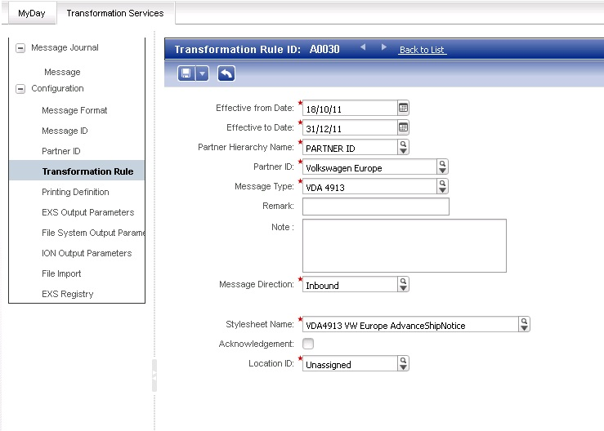

Step 6: Setting up EXS Output Parameters
In this screen the EXS Output Parameters are set. The Message format, Partner ID and the message direction are selected for the message to be processed by EXS.
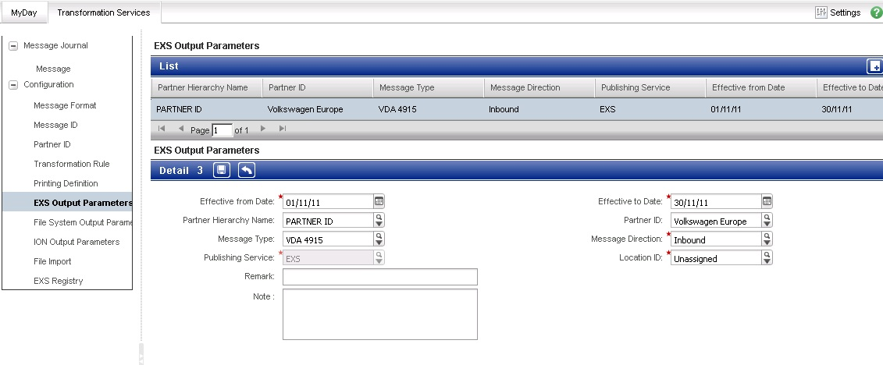
Step 7: Setting up File System Output Parameters
In this screen the File System Output Parameters are set. The Message format, Partner ID and the message direction are selected for the message to be processed by the File System. If this is set for a message, the output file will be generated in the “Out” folder. However, it was hardcoded that the output file would be generated as a “.txt” file. The content for an inbound message would be an XML (BOD) but the extension would be generated as “.txt”. The prefix for the output file can be configured in this screen. The output file name is generated as: <Prefix><yyyyMMddHHmmss>.txt
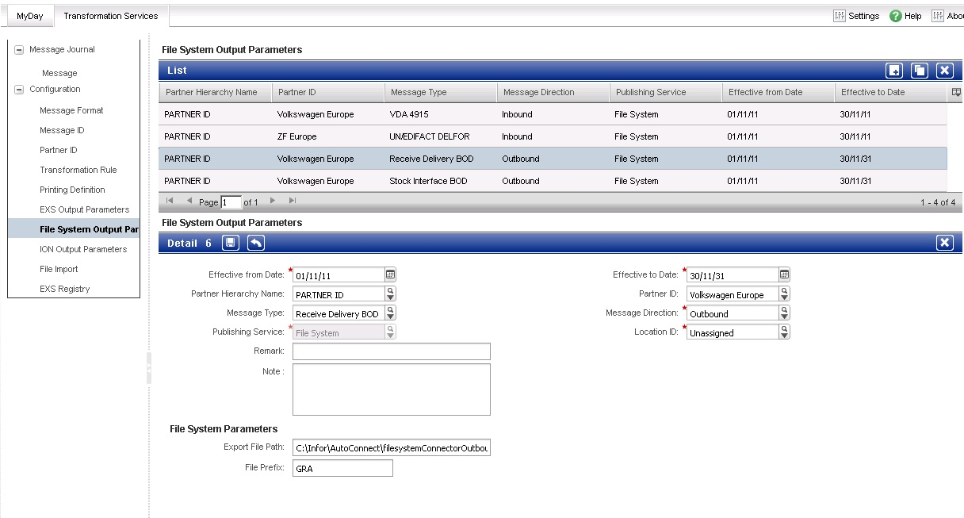
Step 8: Setting up ION Output Parameters
A message can be configured to be processed by ION through this screen. The Message format, Partner ID and the message direction are selected for the message to be processed by ION. The output will be inserted as blob fields in the COR_OUTBOX_HEADER and COR_OUTBOX_ENTRY tables to be picked by LN.
Note: Only one of the above Output Parameters will be processed by Autoconnect.
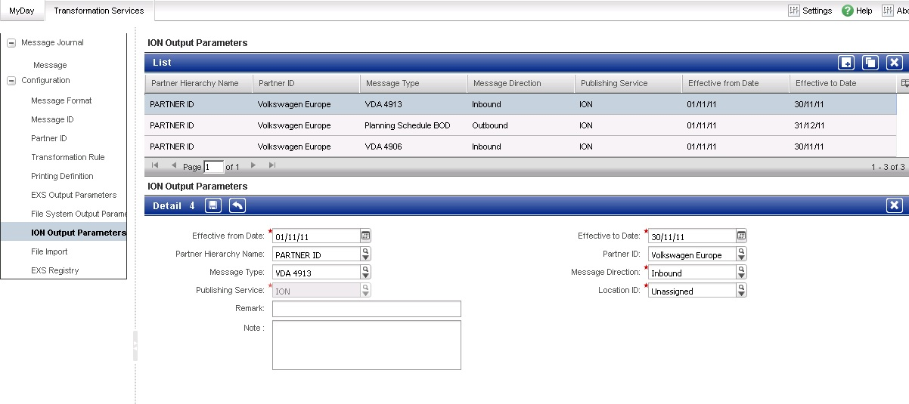

Step 9: Message Journal
This screen shows the processed / processing messages list. When a message is clicked, the Input Message tab contains the input file data, the Target Message tab contains the output file data and the Log Entries tab contains the log messages for the steps of file transformation.
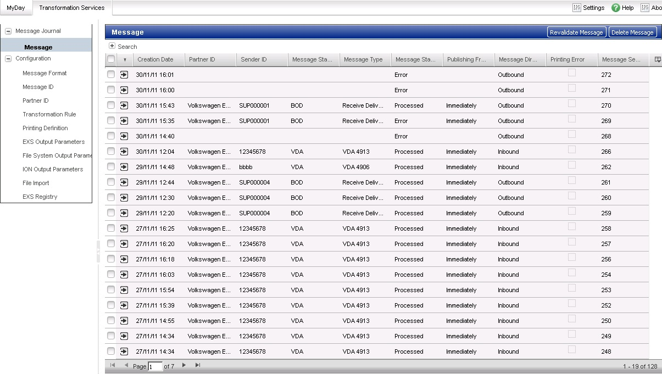

Step 10: Message Details
Click on any message to see the details of the processing. There are 4 tabs viz.
- Source Message: Shows the Source message data.
- Target Message: Shows the target message data.
- Log Entries: Shows the log of the transformation. If any errors occur in the process, they will be showed here.
- Printing Request: Shows the printing request (if any).
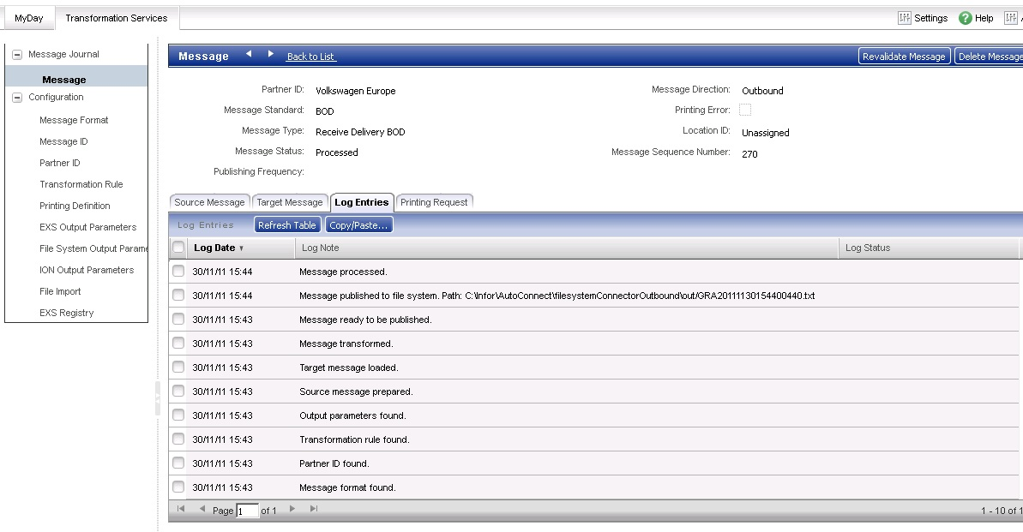

Common issues:
- SyncAlert output with the following message:
<Description languageID="en-US">The message with sequence number 89, partner ID null and message type ReceiveDelivery cannot be processed.</Description>
Reason: The sender and receiver in the input file do not match with the ones specified in the configurations.
Solution: Set the Sender and receivers in the Partner ID that match the input file or correct the input file based on those set in Partner ID screen.
- File is processed but no record in COR_OUTBOX_ENTRY
Observations: Check the message log entries to find out where the error has occurred. If the log entries has “Published to On-Ramp”, there should be a record in the table. If an error has occurred before this log message, fix it. If there are any other “Published to” messages other than ION or On-Ramp, the publishing was done by other output parameter.
Reason: Only one Output Parameter is applied to a message.
Solution: Remove the Output Parameters in other screens (EXS Output Parameters and File System Output Parameters) for this Message Format-Partner ID combination and create/edit the corresponding configuration in ION Output Parameters screen.

