


ID046-CBT Bottomline Interface_BAES_Test-Report


Project Phoenix

Document Information
Author(s) | Ipshita Verma
Version | 1.0
Customer | BAE Systems
Project | Phoenix
Phase | Testing
Status |  Initial  Follow-up

Change Control
Version | Editor | Date | Changes
1.0 | Ipshita Verma | 24-June-2014 | Document Created

Table of Contents

1 Document Information 2
1.1 Change Control 2
3 Introduction 4
3.1 Test scenarios 4
3.2 test Results 5
3.2.1 TEST CASE- TC-01 5
3.2.2 TEST CASE- TC-02 6
3.2.3 TEST CASE- TC-03 7

Introduction

Test scenarios
Test Case | Description of flow | Values to be validated in Baan | Expected result
TC-01 | Go to session Payment/Receipt Method tfcmg0540m000. Create an automatic payment method and attach to it Payment report Bottom-line Bank file.  Maintain Data by Bank/Payment method tfcmg0545m000, for the payment method and a bank. Setup the path for the payment file in this session |  | Payment method and Data by bank/payment method should be created with proper fields
TC-02 | Go to session Payment advices tfcmg1509m000.  Maintain a payment batch; use the payment method and bank as setup in 1st step.  Process the payment batch | Payment method should be mandatory to be filled. | System should validate the payment batch and process it completely.  When the session set up in payment method to generate payment files is completed, the file should be generated.
TC-03 | Check for the payment file generated |  | Payment file should be a comma delimited file with data as per the requirement.

test Results

TEST CASE- TC-01
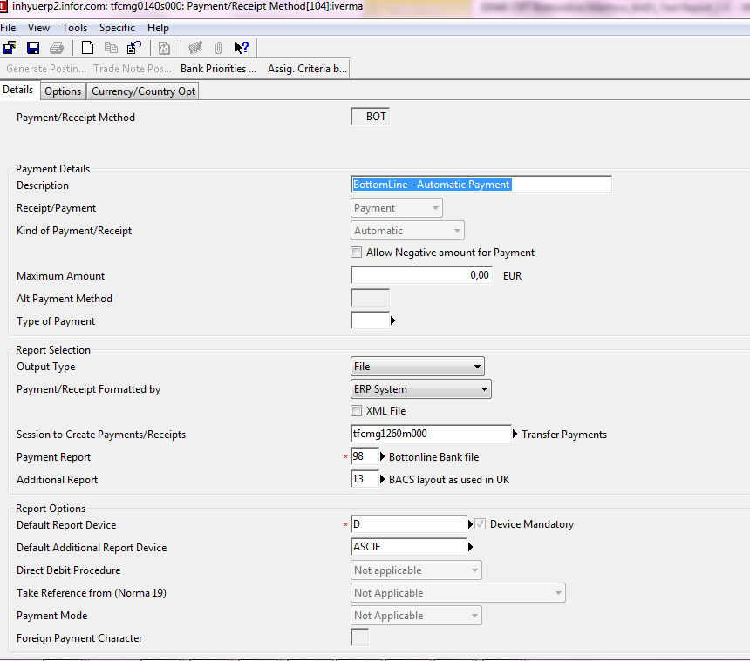
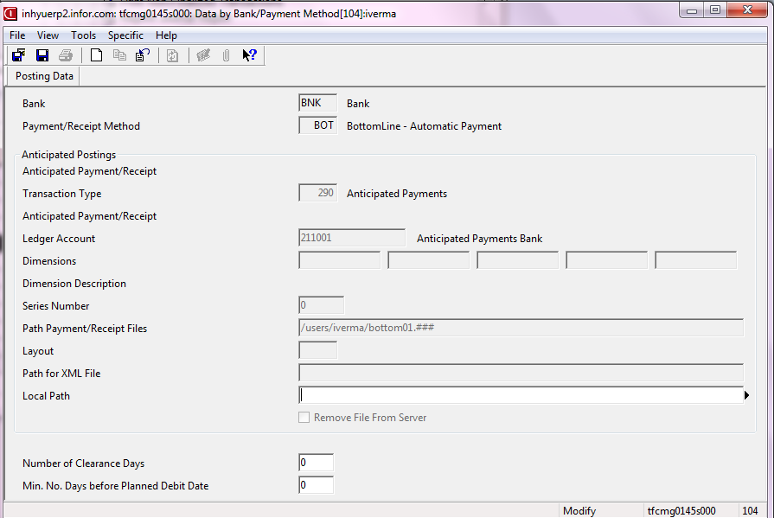

TEST CASE- TC-02
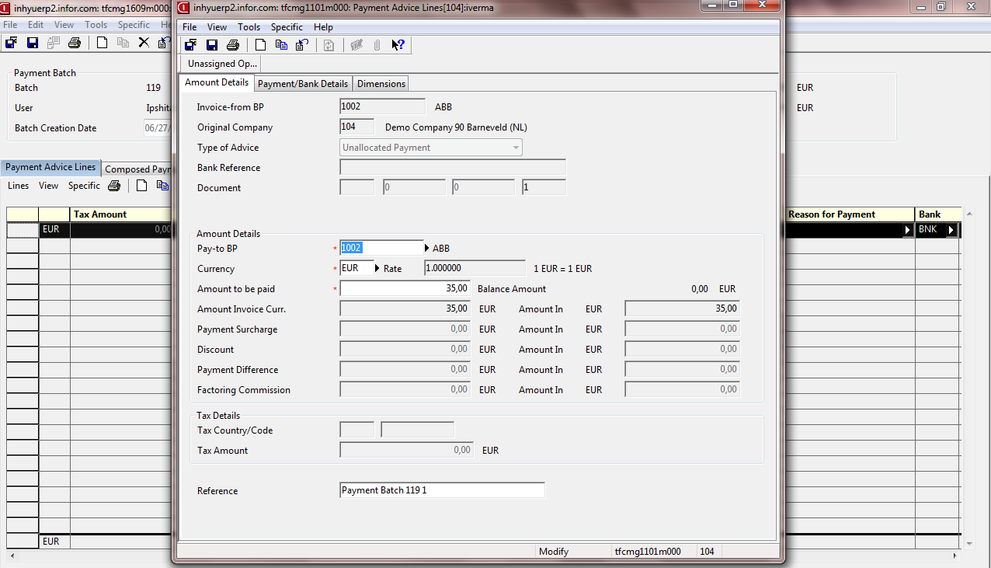
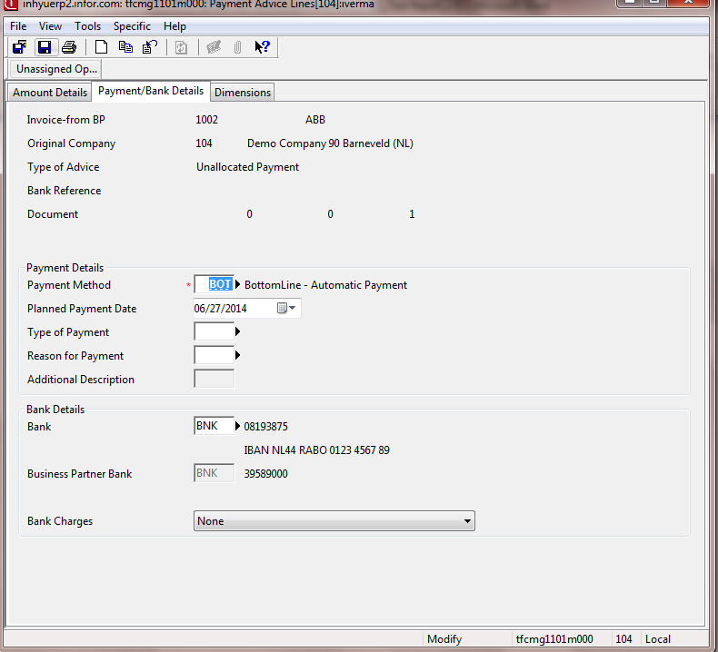

TEST CASE- TC-03

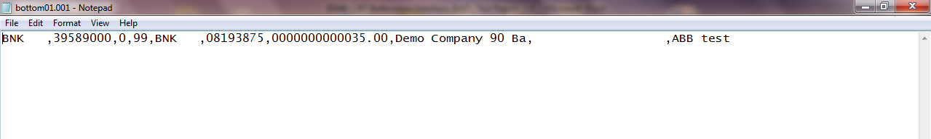

Payee Sort Code –
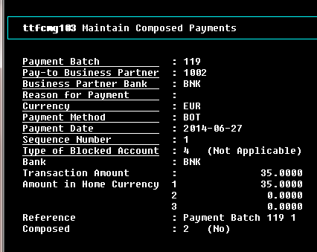
Payee Account Number
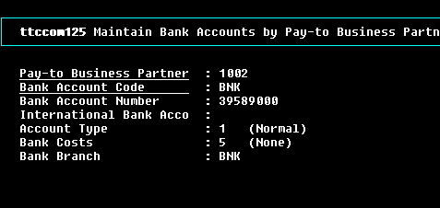
Payee Type of Account – Set as 0
Transaction Code – Set as 99

Originating Sort Code (BAE account) –
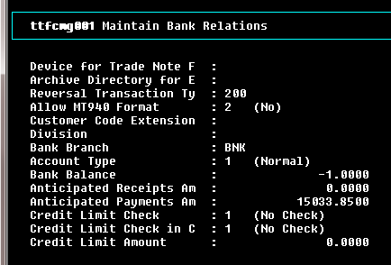
Originating Account No (BAE account)-
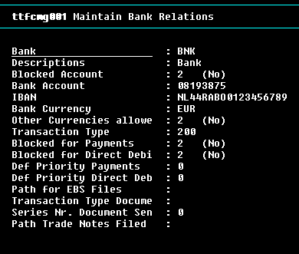
Amount-
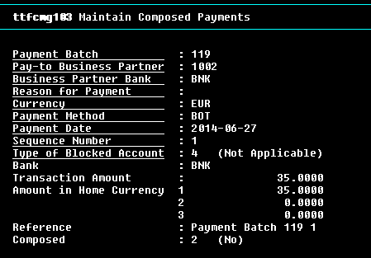
Originating Company Name (BAE) - 18 chars
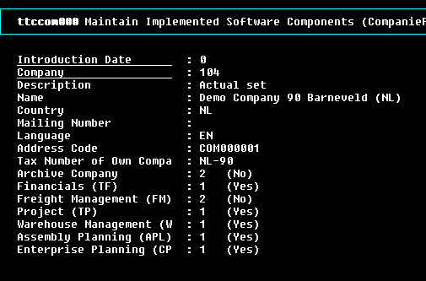
BAE Reference – Set to spaces
Payee Company Name –
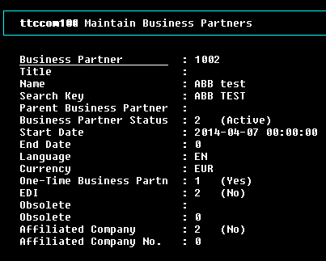

Result: Pass

