



ID025 Controlled Items Manufacturing to AEB ASSIST4
Delivery Document

Document information
Author | Kiran Kadali
Document ID | ID0025F001
Document Version | 0.1
Document Title | ID059 – Loading Firmed Planned Orders
Document Platform | Infor® ERP LN 10.4
Document Reference | 1.0
Status | Draft In Review Approved

Change Control
Version | Date | Status | Reviewer | Changes

Term | Description
ERP | Enterprise Resource Planning
ION | Integrated Open Network, SOA integration platform used by Infor
ASN | Advance Shipment Notice
CKD | Completely Knocked Down Kit
BOD | Business Object Definition
EDI | Electronic Data Interchange
XML | Extended Mark-up Language
WH | Infor® ERP_{LN} Warehousing Package
TC | Infor® ERP_{LN} Common Package
LCT | Infor® ERP_{LN} Landed Costs
CMG | Infor® ERP_{LN} Cash Management
PPC | Infor® ERP_{LN} Project production Contol
CTM | Infor® ERP_{LN} Contract Module
ACP | Infor® ERP_{LN} Accounts Payable
INA | Infor® ERP_{LN} Inventory Analysis
RRP | Infor® ERP_{LN} Resource Requirement planning
CCP | Infor® ERP_{LN} Central calendar Management
PPL | Infor® ERP_{LN} People
FAM | Infor® ERP_{LN} Fixed Assets Management
BAES | Infor® ERP_{LN} BAES Customization Package
XSLT | Extensible Stylesheet Language Transformations

Content
1 Introduction 5
2 Infor ERP LN Components 6
2.1 PMC 6
2.2 New or modified Server components 6
3 Infor ION-Connect Components 9
4 Infor ION-Process Components 10

Introduction

The Solution contains the components for the below requirement
ID025 Controlled Items Manufacturing to AEB ASSIST4

Infor ERP LN Components

PMC
PMC | Description | Dependencies
ID0025F001 | ID025 Controlled Items Manufacturing to AEB ASSIST4 | IW030E002

New or modified Server components
Component Type | Component | Description | New/Modified | Dump Path
Library | Whinh220ue | UE for Outbound Order Lines | New
Business Object | Boinh914 | InboundOrderLine_BAES | Modified
Business Object | Boinh921 | OutboundOrderLine_BAES | New
Label | Boinh921 | OutboundOrderLine_BAES | New

Note : Once the solution is installed, Register the OutboundOrderLine_BAESBOD and in ERPLN in Respective companies(bobod1100m000)

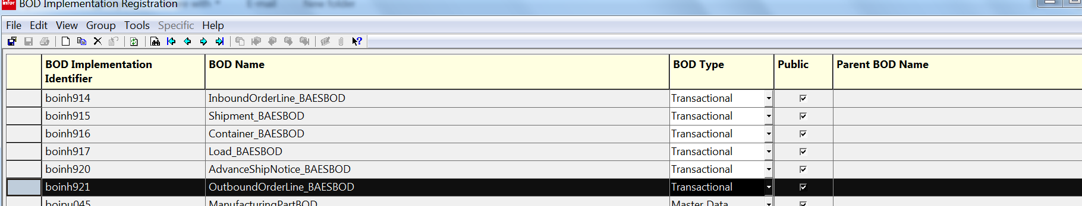

Infor ION-Connect Components

- The ION Registry need to be changed for InboundOrderLine_BAES BOD and need to register OutboundOrderLine_BAES BOD.
- Modify ERPLN Connection point and Specify Sync.OutboundOrderLine_BAES bod as Send From Application.
- Modify Bizagi application and specify Process.OutboundOrderLine_BAES bod as Write to Queue.

Infor ION-Process Components
N.A

