



interface
ID003 – Exostar Interface

Document information

Author | Manish Adlak
Document ID | ID003 – Exostar Interface
Document Version | 1.0
Document Title | interface
Document Platform | Infor® ERP LN Fp10
Document Reference
Status | Draft In Review Approved

Change Control
Version | Date | Status | Reviewer | Changes
1.0 | 08/28/2015 | Initial |  | New

Term | Description
ERP | Enterprise Resource Planning
ION | Integrated Open Network, SOA integration platform used by Infor
ASN | Advance Shipment Notice
CKD | Completely Knocked Down Kit
BOD | Business Object Definition
EDI | Electronic Data Interchange
XML | Extended Mark-up Language
WH | Infor® ERP_{LN} Warehousing Package
TC | Infor® ERP_{LN} Common Package
LCT | Infor® ERP_{LN} Landed Costs
CMG | Infor® ERP_{LN} Cash Management
PPC | Infor® ERP_{LN} Project production Contol
CTM | Infor® ERP_{LN} Contract Module
ACP | Infor® ERP_{LN} Accounts Payable
INA | Infor® ERP_{LN} Inventory Analysis
RRP | Infor® ERP_{LN} Resource Requirement planning
CCP | Infor® ERP_{LN} Central calendar Management
PPL | Infor® ERP_{LN} People
FAM | Infor® ERP_{LN} Fixed Assets Management
BAES | Infor® ERP_{LN} BAES Customization Package

Contents
1 Introduction 5
2 Bill of Deliverables 6
3 Infor ERP LN Components 7
3.1 PMC – ID003F001 7
3.1.1 PMC Components 7
3.1.2 Post Installation Instructions 7
4 Infor ION Configuration 8

Introduction

This delivery is for the ID003 – Exostar interface. It contains both LN PMCs as well as ION components pertaining to this interface.

Bill of Deliverables
This delivery contains the following components –
- LN PMCs –
  - ID003F001.tar.gz – this packages the components of custom development for this interface.
- ION Custom Registry components – ID003F001_ION.zip.
- Delivery Document - ID003F001_Delivery_Document.doc (this document).

Infor ERP LN Components

PMC – ID003F001
PMC | Description | Dependencies
ID003F001 | ID003 - Exostar Interface(ASN) | None

PMC Components
Component Type | Component | Description | New/Modified | Dump Path
Business Object | boinh920 | AdvanceShipNotice_BAES | New
Label | Boinh910 | AdvanceShipNotice_BAES | New
Script/Library Object | whboddllc003 | Supporting DLL for AdvanceShipNotice_BAES BOD | New

Post Installation Instructions
As this PMC contains Labels for Business Objects it is necessary to perform a CRDD (Convert to Runtime Data Dictionary).
(bobod1100m000).
Register the new Business Objects installed above in the BOD Implementation Registration Session (bobod1100m000).
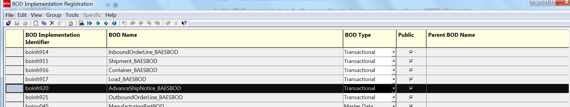

Infor ION Configuration
The following two custom BODs have to be registered in ION registry for further use in ION.
AdvanceShipNotice_BAES

- Modify ERPLN Connection point add Process.AdvanceShipNotice_BAES can be received.
- Modify Bizagi connection point and specify Process.AdvanceShipNotice_BAES can be read from queue and Acknowledge.AdvanceShipNotice_BAES can be write to queue.

