



iW018- Receiving Prompts Workflow
Delivery Document

Document information

Author | Sattiraju Namala
Document ID | IW018F001
Document Version | 0.1
Document Title | ID018 – Receiving Prompts Workflow
Document Platform | Infor® ERP LN 10.4
Document Reference | 1.0
Status | Draft In Review Approved

Change Control
Version | Date | Status | Reviewer | Changes
0.1 | 06/02/2015 | Initial |  | New

Term | Description
ERP | Enterprise Resource Planning
ION | Integrated Open Network, SOA integration platform used by Infor
ASN | Advance Shipment Notice
CKD | Completely Knocked Down Kit
BOD | Business Object Definition
EDI | Electronic Data Interchange
XML | Extended Mark-up Language
WH | Infor® ERP_{LN} Warehousing Package
TC | Infor® ERP_{LN} Common Package
LCT | Infor® ERP_{LN} Landed Costs
CMG | Infor® ERP_{LN} Cash Management
PPC | Infor® ERP_{LN} Project production Contol
CTM | Infor® ERP_{LN} Contract Module
ACP | Infor® ERP_{LN} Accounts Payable
INA | Infor® ERP_{LN} Inventory Analysis
RRP | Infor® ERP_{LN} Resource Requirement planning
CCP | Infor® ERP_{LN} Central calendar Management
PPL | Infor® ERP_{LN} People
FAM | Infor® ERP_{LN} Fixed Assets Management
BAES | Infor® ERP_{LN} BAES Customization Package
XSLT | Extensible Stylesheet Language Transformations

Content
1 Introduction 5
2 Infor ERP LN Components 6
2.1 PMC 6
2.2 New or modified Server components 6
3 Infor ION-Connect Components 9
4 Infor ION-Process Components 10

Introduction

The Solution contains the components for the below requirement

IW018 – Receiving Prompts Workflow

Infor ERP LN Components

PMC
PMC | Description | Dependencies
IW018F001 | IW018- Receiving Prompts | NA

New or modified Server components
Component Type | Component | Description | New/Modified | Dump Path
Business Object | Boinh914 | InboundOrderLines_BAES | New
Label | Boinh914 | InboundOrderLines_BAES | New
Library | Whinh210ue | User Exit for Inbound Order Lines | New

Note : Once the solution is installed run CRDD for label and Register the InboundOrderLines _BAES BOD in ERPLN in Respective companies(bobod1100m000)
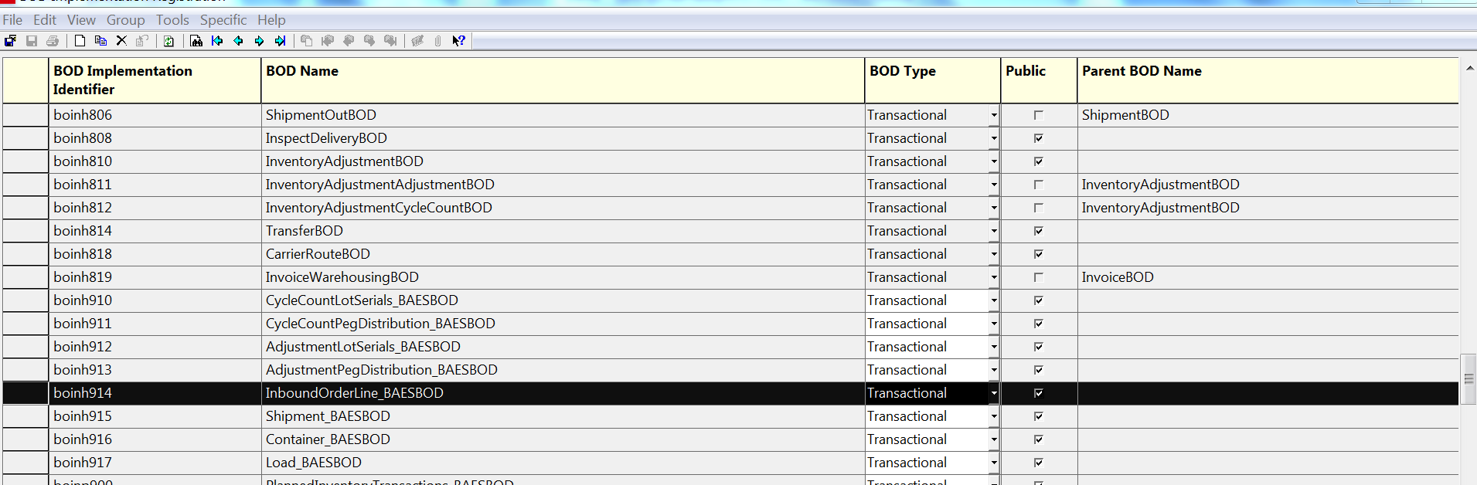

Infor ION-Connect Components

  - the InboundOrderLines_BAES BOD needs to be registered in ION.

  - Modify the ERPLN Connection Point and Add Sync. InboundOrderLines_BAES BOD can be published.
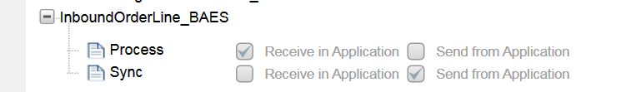

  - Modify the Bizagi Connection Point Add Sync. InboundOrderLines _BAES BOD can be received.
  - Modify the Document flows and ADD InboundOrderLines_BAES BOD.

Infor ION-Process Components
N.A

