



ID080- Customer Owned Asset InterfaCe DEsign
Delivery Document

Document information

Author | Sattiraju Namala
Document ID | ID080F001
Document Version | 0.1
Document Title | ID080
Document Platform | Infor® ERP LN 10.4
Document Reference | 1.0
Status | Draft In Review Approved

Change Control
Version | Date | Status | Reviewer | Changes
0.1 | 13/11/2015 | Initial |  | New

Term | Description
ERP | Enterprise Resource Planning
ION | Integrated Open Network, SOA integration platform used by Infor
ASN | Advance Shipment Notice
CKD | Completely Knocked Down Kit
BOD | Business Object Definition
EDI | Electronic Data Interchange
XML | Extended Mark-up Language
WH | Infor® ERP_{LN} Warehousing Package
TC | Infor® ERP_{LN} Common Package
LCT | Infor® ERP_{LN} Landed Costs
CMG | Infor® ERP_{LN} Cash Management
PPC | Infor® ERP_{LN} Project production Contol
CTM | Infor® ERP_{LN} Contract Module
ACP | Infor® ERP_{LN} Accounts Payable
INA | Infor® ERP_{LN} Inventory Analysis
RRP | Infor® ERP_{LN} Resource Requirement planning
CCP | Infor® ERP_{LN} Central calendar Management
PPL | Infor® ERP_{LN} People
FAM | Infor® ERP_{LN} Fixed Assets Management
BAES | Infor® ERP_{LN} BAES Customization Package
XSLT | Extensible Stylesheet Language Transformations

Content
1 Introduction 5
2 Infor ERP LN Components 6
2.1 PMC 6
2.2 New or modified Server components 6
3 Infor ION-Connect Components 7
4 Infor ION-Process Components 8

Introduction
This Delivery contains intial Delivery for ID080

Infor ERP LN Components

PMC
PMC | Description | Dependencies
ID080F001 | PNX 2827- PNX 3027 | ID074F001

New or modified Server components
Component Type | Component | Description | New/Modified | Dump Path
Business Object | Boinh922 | InventoryAdjustment_BAES | New
Script/library object | Whboddllc9004 | Supporting dll for InventoryAdjustment _BAES | New
Script/library object | Boppcbl031cc00 | CC script for Project History BOD | Modified
Label | Boinh922 | InventoryAdjustment_BAES | New

Note :After installing this solution InventoryAdjustment_BAES BOD need to be registered in BOM Implementation Registration (bobod1100m000)

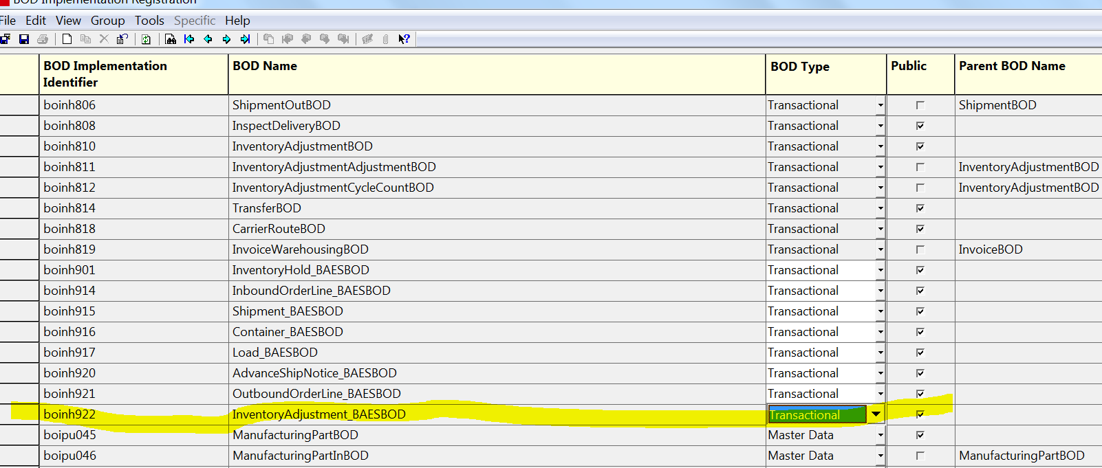

Infor ION-Connect Components

For the Below BODS ION Registration need to be changed.

InventoryAdjustment_BAES

Infor ION-Process Components
N.A

