



ID068 - EMS-Infor LN Spec Equipment Interface POM Only InterfaCe DEsign
Delivery Document

Document information

Author | Sattiraju Namala
Document ID | ID068 - EMS-Infor LN Spec Equipment Interface POM Only
Document Version | 0.1
Document Title | ID068
Document Platform | Infor® ERP LN 10.4
Document Reference | 1.0
Status | Draft In Review Approved

Change Control
Version | Date | Status | Reviewer | Changes
0.1 | 11/01/2016 | Initial |  | New

Term | Description
ERP | Enterprise Resource Planning
ION | Integrated Open Network, SOA integration platform used by Infor
ASN | Advance Shipment Notice
CKD | Completely Knocked Down Kit
BOD | Business Object Definition
EDI | Electronic Data Interchange
XML | Extended Mark-up Language
WH | Infor® ERP_{LN} Warehousing Package
TC | Infor® ERP_{LN} Common Package
LCT | Infor® ERP_{LN} Landed Costs
CMG | Infor® ERP_{LN} Cash Management
PPC | Infor® ERP_{LN} Project production Contol
CTM | Infor® ERP_{LN} Contract Module
ACP | Infor® ERP_{LN} Accounts Payable
INA | Infor® ERP_{LN} Inventory Analysis
RRP | Infor® ERP_{LN} Resource Requirement planning
CCP | Infor® ERP_{LN} Central calendar Management
PPL | Infor® ERP_{LN} People
FAM | Infor® ERP_{LN} Fixed Assets Management
BAES | Infor® ERP_{LN} BAES Customization Package
XSLT | Extensible Stylesheet Language Transformations

Content
1 Introduction 5
2 Infor ERP LN Components 6
2.1 PMC 6
2.2 New or modified Server components 6
3 Infor ION-Connect Components 9
4 Infor ION-Process Components 10

Introduction
This Delivery contains intial Delivery for ID068

Infor ERP LN Components

PMC
PMC |  | Dependencies
ID068F001 | EMS-Infor LN Spec Equipment Interface POM Only | CR228E001, IW028E002, UDF034

New or modified Server components
Component Type | Component | Description | New/Modified | Dump Path
Script/library object | Boinhbl802cc00 |  | Modified
Script/library object | Bopurbl049cc00 |  | Modified
Script/library object | Tdboddllc002 |  | New
Business Object | Bopur907 |  | New
Label | Bopur907 |  | New

Note: After Installing the PMC solution below BOD need to be registered in BOD Implementation registration (bobod1100m000)
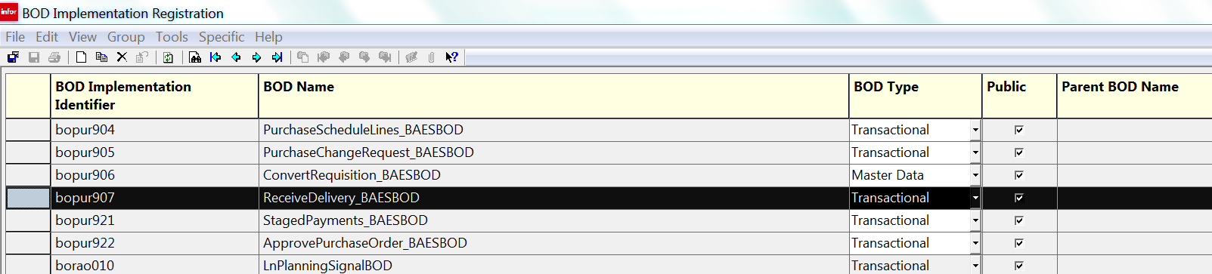

Infor ION-Connect Components

The Below BOD need to be registered in ION.
ReceiveDelivery_BAES.

Infor ION-Process Components
N.A

