



iD044- CBT Excel CAS Cash Allocation for interface
Delivery Document

Document information

Author | Sattiraju Namala
Document ID | ID044F001
Document Version | 0.1
Document Title | ID044 – CBT Excel CAS Cash Allocation for interface
Document Platform | Infor® ERP LN 10.4
Document Reference | 1.0
Status | Draft In Review Approved

Change Control
Version | Date | Status | Reviewer | Changes
0.1 | 03/08/2015 | Initial |  | New

Term | Description
ERP | Enterprise Resource Planning
ION | Integrated Open Network, SOA integration platform used by Infor
ASN | Advance Shipment Notice
CKD | Completely Knocked Down Kit
BOD | Business Object Definition
EDI | Electronic Data Interchange
XML | Extended Mark-up Language
WH | Infor® ERP_{LN} Warehousing Package
TC | Infor® ERP_{LN} Common Package
LCT | Infor® ERP_{LN} Landed Costs
CMG | Infor® ERP_{LN} Cash Management
PPC | Infor® ERP_{LN} Project production Contol
CTM | Infor® ERP_{LN} Contract Module
ACP | Infor® ERP_{LN} Accounts Payable
INA | Infor® ERP_{LN} Inventory Analysis
RRP | Infor® ERP_{LN} Resource Requirement planning
CCP | Infor® ERP_{LN} Central calendar Management
PPL | Infor® ERP_{LN} People
FAM | Infor® ERP_{LN} Fixed Assets Management
BAES | Infor® ERP_{LN} BAES Customization Package
XSLT | Extensible Stylesheet Language Transformations

Content
1 Introduction 5
2 Infor ERP LN Components 6
2.1 PMC 6
2.2 New or modified Server components 6
3 Infor ION-Connect Components 8
4 Infor ION-Process Components 9

Introduction

The Solution contains the components for the below requirement

ID044– CBT Excel CAS Cash Allocation for interface

Infor ERP LN Components

PMC
PMC | Description | Dependencies
ID044F001 | CR for CustomerRemittanceAdvice_BAES BOD

New or modified Server components
Component Type | Component | Description | New/Modified | Dump Path
Business Object | Bocmg906 | CustomerRemittanceAdvice_BAES | New
Label | Bocmg906 | CustomerRemittanceAdvice_BAES | New
Library | Tfcmgdllc9002 | Supporting DLL for CustomerRemittanceAdvice_BAES BOD | New
Message | Tfcmgs0001.c | Error During Aplly Process for Remittance Line”%1$s” | New
Message | Tfcmgs0002.c | No valid lines found for Apply Process or All Lines gone through the process | New

Note: once the Solution is installed please register CustomerRemittanceAdvice_BAES bod in BOD Implementation Registration(bobod1100m000) session.
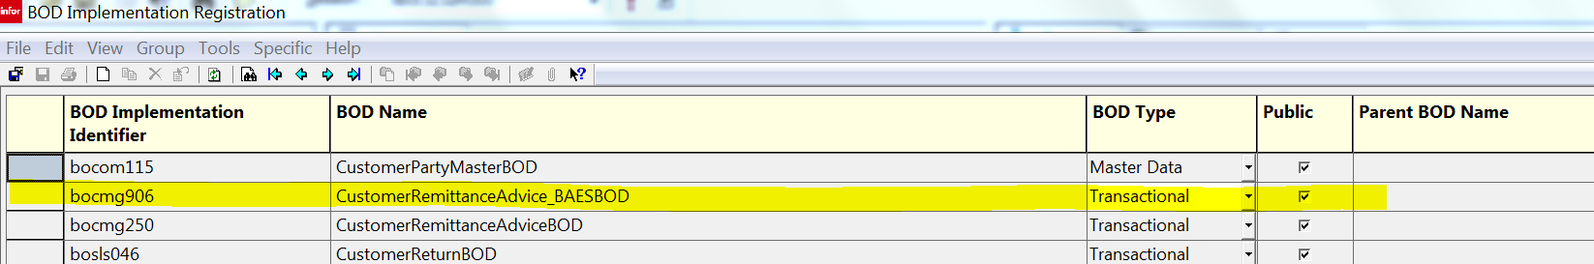

Infor ION-Connect Components

  - The CustomerRemittanaceAdvice_BAES BOD need to be registered in ION.
  - Modify ERPLN Connection point and Add Process.CustomerRemittanceAdvice_BAES BOD can be received.
  - Modify Bizagi connection point and Add Process.CustomerRemittanceAdvice_BAES BOD can be read and Acknowledge.CustomerRemittanceAdvice_BAES bod as write.

Infor ION-Process Components
N.A

