



id043- CBT– ETC INTERFACE
Delivery Document

Document information

Author | Sravanthi Mannepalli
Document ID | ID043F001
Document Version | 0.1
Document Title | ID043 - CBT– ETC INTERFACE
Document Platform | Infor® ERP LN Fp9
Document Reference | 1.8
Status | Draft In Review Approved

Change Control
Version | Date | Status | Reviewer | Changes
0.1 | 27/06/2014 | Initial |  | New

Term | Description
ERP | Enterprise Resource Planning
ION | Integrated Open Network, SOA integration platform used by Infor
ASN | Advance Shipment Notice
CKD | Completely Knocked Down Kit
BOD | Business Object Definition
EDI | Electronic Data Interchange
XML | Extended Mark-up Language
WH | Infor® ERP_{LN} Warehousing Package
TC | Infor® ERP_{LN} Common Package
LCT | Infor® ERP_{LN} Landed Costs
CMG | Infor® ERP_{LN} Cash Management
PPC | Infor® ERP_{LN} Project production Contol
CTM | Infor® ERP_{LN} Contract Module
ACP | Infor® ERP_{LN} Accounts Payable
INA | Infor® ERP_{LN} Inventory Analysis
RRP | Infor® ERP_{LN} Resource Requirement planning
CCP | Infor® ERP_{LN} Central calendar Management
PPL | Infor® ERP_{LN} People
FAM | Infor® ERP_{LN} Fixed Assets Management
BAES | Infor® ERP_{LN} BAES Customization Package
XSLT | Extensible Stylesheet Language Transformations

Content
1 Introduction 5
2 Infor ERP LN Components 6
2.1 PMC 6
2.2 New or modified Server components 6
3 Infor ION-Connect Components 9
4 Infor ION-Process Components 10

Introduction

The Solution contains the components for the below interface requirement

ID043 – CBT – ETC INTERFACE

Infor ERP LN Components

PMC
PMC | Description | Dependencies
ID043F001 | CBT – ETC INTERFACE | ID086

New or modified Server components
Component Type | Component | Description | New/Modified | Dump Path
Business Object | boacp906 | SalesInvoice_BAES | New
Library | tfacpdllc9006 | Support DLL for SalesInvoice Creation | New
Library | tfacpdllc9007 | DLL for Parsing SalesInvoice_BAESBOD | New
Label | boacp906 | SalesInvoice_BAES | New
Message | tfacp9006.c01 | Dimension not Allowed for Ledger Account %1$s | New
Message | tfacp9007.1.c | Line %1$s Failed | New
Message | tfacp9007.2.c | Dimension Codes Count Cannot be More than 12 | New

Note : Once the solution is installed Register the SalesInvoice_BAES BOD in ERPLN in Respective companies(bobod1100m000)

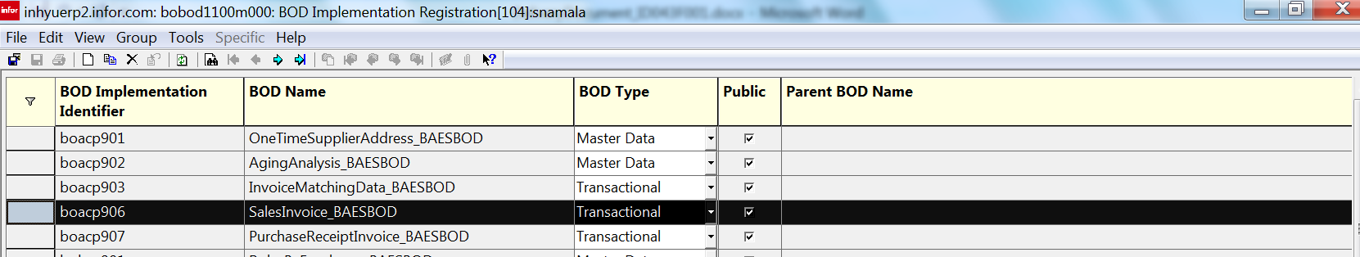

Infor ION-Connect Components

  - the SalesInvoice_BAES BOD needs to be registered in ION.
3.1.1) unzip the Developer.zip file and copy the content to <ION_Installed_Folder>\Desk\bin\RegistryData\BodMetaData\Custom\BODs\Developer folder
3.1.2) Unzip the Nouns.zip file and copy the Content Info <ION_Installed_Folder>\Desk\bin\RegistryData\BodMetaData\Custom\Resources\Nouns folder
3.1.3) Unzip the XML.zip file and copy the content into <ION_Installed_Folder>\Desk\bin\RegistryData\BodMetaData\Custom\XML folder

  - Modify the ERPLN Connection Point and Add Process.SalesInvoice_BAES document as Receive in Application.
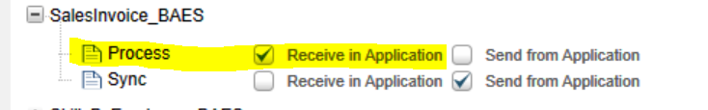

- Modify the Bizagi Connection Point and Add Process.SalesInvoice_BAES can be read from JMS queue.
- Create a document flow with ERPLN connection point as the first activity and Bizagi as second activity and select Process.SalesInvoice_BAES as document.

Infor ION-Process Components
N.A

