

id014- AutoJournals Interface
Delivery Document

Document information

Author | Sravanthi Mannepalli
Document ID | ID014F001
Document Version | 0.1
Document Title | ID014 - AutoJournals Interface Design
Document Platform | Infor® ERP LN Fp9
Document Reference | ID014 - AutoJournals Interface Design (GLE014) v2.2
Status | Draft In Review Approved

Change Control
Version | Date | Status | Reviewer | Changes
0.1 | 07/07/2014 | Initial |  | New

Term | Description
ERP | Enterprise Resource Planning
ION | Integrated Open Network, SOA integration platform used by Infor
ASN | Advance Shipment Notice
CKD | Completely Knocked Down Kit
BOD | Business Object Definition
EDI | Electronic Data Interchange
XML | Extended Mark-up Language
WH | Infor® ERP_{LN} Warehousing Package
TC | Infor® ERP_{LN} Common Package
LCT | Infor® ERP_{LN} Landed Costs
CMG | Infor® ERP_{LN} Cash Management
PPC | Infor® ERP_{LN} Project production Contol
CTM | Infor® ERP_{LN} Contract Module
ACP | Infor® ERP_{LN} Accounts Payable
INA | Infor® ERP_{LN} Inventory Analysis
RRP | Infor® ERP_{LN} Resource Requirement planning
CCP | Infor® ERP_{LN} Central calendar Management
PPL | Infor® ERP_{LN} People
FAM | Infor® ERP_{LN} Fixed Assets Management
BAES | Infor® ERP_{LN} BAES Customization Package
XSLT | Extensible Stylesheet Language Transformations

Content
1 Introduction 5
2 Infor ERP LN Components 6
2.1 PMC 6
2.2 New or modified Server components 6
3 Infor ION-Connect Components 7
4 Infor ION-Process Components 8

Introduction

The Solution contains the components for the below interface requirement

ID014 - AutoJournals Interface Design (GLE014)

Infor ERP LN Components

2.1 PMC
PMC | Description | Dependencies
ID014F001 | ID014 – Auto Journals Interface Design | ID086

2.2 New or modified Server components
Component Type | Component | Description | New/Modified | Dump Path
Business Object | bogld906 | FinancialTransaction _BAES BOD | New
Business Object | bogld908 | FinancialTransactionIN _BAES BOD | New
Library | tfbiadllc9006 | Support DLL for Financial Transaction BOD | New
Library | tfbiadllc9008 | Support DLL for Financial Transaction BOD Incoming | New
Library | tfglddllc9001 | DLL for Batch Creation | New
Library | tfglddllc9002 | DLL for creating Journal Header and Line | New
Library | tpppcdllc9001 | DLL for creating Project Costs | New
Label | bogld906 | FinancialTransaction _BAES BOD | New
Label | bogld908 | FinancialTransactionIN _BAES BOD | New
Message | tfgld.c9002.01 | Ledger Account not present | New
Message | tfgld.c9002.02 | Dimension %1$s is mandotory | New
Message | tfbia.c9008.01 | Entering ‘%1$s’ Costs not allowe. Ledger Account ‘%2$s’ not set for ‘ Project Costs’ | New
Message | tfbia.c9008.02 | Transaction Type of Category %1$s is not allowed for Processing | New

Note : Convert to runtime required for labels.
Once the solution is installed the following BOD registration needs to be done in ERPLN Company.
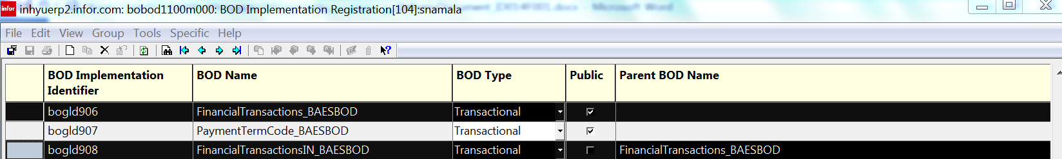

Infor ION-Connect Components
3.1) the financial Transaction BOD needs to be registered in ION.
3.1.1) unzip the Developer.zip file and copy the content to <ION_Installed_Folder>\Desk\bin\RegistryData\BodMetaData\Custom\BODs\Developer folder

3.1.2) Unzip the Nouns.zip file and copy the Content Info <ION_Installed_Folder>\Desk\bin\RegistryData\BodMetaData\Custom\Resources\Nouns folder

3.1.3) Unzip the XML.zip file and copy the content into <ION_Installed_Folder>\Desk\bin\RegistryData\BodMetaData\Custom\XML folder

3.2) Modify the ERPLN connection point and add the FinancialTransactions_BAES BOD as
Process Receive and Sync can be published


3.3) Modify Bizagi connection point and configure FinancialTransactions_BAES BOD as Process Read from queue and Sync write into queue.

3.4) Create document flow for this BOD and activate the document flow

Infor ION-Process Components
N.A

