



id005-EMPLOYEE PEOPLE PORTAL INTERFACE
Delivery Document

Document information

Author | Kiran Kolluri
Document ID | ID005F001
Document Version | 0.1
Document Title | ID005-EMPLOYEE PEOPLE PORTAL INTERFACE
Document Platform | Infor® ERP LN Fp9
Document Reference | 1.8
Status | Draft In Review Approved

Change Control
Version | Date | Status | Reviewer | Changes
0.1 | 25/06/2014 | Initial |  | New

Term | Description
ERP | Enterprise Resource Planning
ION | Integrated Open Network, SOA integration platform used by Infor
ASN | Advance Shipment Notice
CKD | Completely Knocked Down Kit
BOD | Business Object Definition
EDI | Electronic Data Interchange
XML | Extended Mark-up Language
WH | Infor® ERP_{LN} Warehousing Package
TC | Infor® ERP_{LN} Common Package
LCT | Infor® ERP_{LN} Landed Costs
CMG | Infor® ERP_{LN} Cash Management
PPC | Infor® ERP_{LN} Project production Contol
CTM | Infor® ERP_{LN} Contract Module
ACP | Infor® ERP_{LN} Accounts Payable
INA | Infor® ERP_{LN} Inventory Analysis
RRP | Infor® ERP_{LN} Resource Requirement planning
CCP | Infor® ERP_{LN} Central calendar Management
PPL | Infor® ERP_{LN} People
FAM | Infor® ERP_{LN} Fixed Assets Management
BAES | Infor® ERP_{LN} BAES Customization Package
XSLT | Extensible Stylesheet Language Transformations

Content
1 Introduction 5
2 Infor ERP LN Components 6
2.1 PMC 6
2.2 New or modified Server components 6
3 Infor ION-Connect Components 9
4 Infor ION-Process Components 10

Introduction

The Solution contains the components for the below interface requirement

ID005 – Employee People Portal Interface

Infor ERP LN Components

PMC
PMC | Description | Dependencies
ID005F001 | Employee People Portal Interface | NA

New or modified Server components
Component Type | Component | Description | New/Modified | Dump Path
Business Object Layer | bocombl004cc00 | CC for PersonIn BOD | New

Infor ION-Connect Components

- Modify the ERPLN Connection Point and Add Process.Person document as Receive in Application.


- Modify the Bizagi Connection Point and Add Process.Person can be read from JMS queue.
- Create a document flow with ERPLN connection point as the first activity and Bizagi as second activity and select Process.Person as document.
- Import the following XSLT and apply this xslt in above document flow.

Attached XSLT mapping to be imported

  - XSLT Mapping
Import XSLT Mappings from folder < UnZip >\Connection_Point\XSLT_Mapping
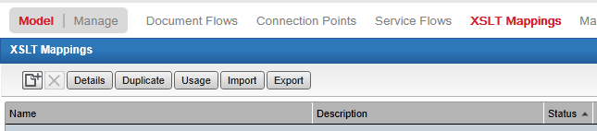

-> Click “Import” on XSLT Mapping and select the XSLT mapping xml from “XSLT_Mapping” Folder

Infor ION-Process Components
N.A

