

ION ALERTS

Delivery Document

Document information

Author | Rajashekar Pothiganti
Document ID | IAF001
Document Version | 0.1
Document Title | ION Alerts Solution
Document Platform | Infor® ERP LN Fp9
Document Reference
Status | Draft In Review Approved

Change Control
Version | Date | Status | Reviewer | Changes
0.1 | 06/27/2014 | Initial |  | New

Term | Description
ERP | Enterprise Resource Planning
ION | Integrated Open Network, SOA integration platform used by Infor
ASN | Advance Shipment Notice
CKD | Completely Knocked Down Kit
BOD | Business Object Definition
EDI | Electronic Data Interchange
XML | Extended Mark-up Language
WH | Infor® ERP_{LN} Warehousing Package
TC | Infor® ERP_{LN} Common Package
LCT | Infor® ERP_{LN} Landed Costs
CMG | Infor® ERP_{LN} Cash Management
PPC | Infor® ERP_{LN} Project production Contol
CTM | Infor® ERP_{LN} Contract Module
ACP | Infor® ERP_{LN} Accounts Payable
INA | Infor® ERP_{LN} Inventory Analysis
RRP | Infor® ERP_{LN} Resource Requirement planning
CCP | Infor® ERP_{LN} Central calendar Management
PPL | Infor® ERP_{LN} People
FAM | Infor® ERP_{LN} Fixed Assets Management
BAES | Infor® ERP_{LN} BAES Customization Package

Content
1 Introduction 5
2 Infor ERP LN Components 6
2.1 PMC 6
2.2 New or modified Server components 6
3 Infor ION-Connect Components 9
4 Infor ION-Process Components 10

Introduction

The Solution contains the components for the below Alerts design

IA003 | GL_Journal Exceeding Value V1.1
IA006 | Business Partner Creation Alert V2.0
IA010 | GL_Journal Specific GL codes v1.1
IA012 | Cash_Employee BP v1.1
IA016 | Cash Payt Advice created v1.1
IA018 | RFQ Buyer Notification Alert Design v1.3
IA019 | Work Authorization Alert Design v1 2
IA020 | Zero Priced Sales Orders Alert Design v1 2
IA021 | Purchase Contract Due To Expire v1.4
IA022 | Receipt of FoC Repaired Item v1 1
IA023 | ACP Invoices on Hold v1 2
IA024 | ACP Invoices Overdue 1 2
IA025 | Change of charge dept alert design 1 1
IA026 | Buyer Alert for Warranty Purchase Order 1 1
IA027 | Assets in Service Alert v1 2
IA030 | DTC item not shipped to BAE address v1 1
IA031 | Commercial Budget Released V1.1
IA032 | Project Readiness Closure alert

Infor ERP LN Components

2.1 PMC
PMC | Description | Dependencies
IAF001 | ION Alerts Solution | NA

2.2 New or modified Server components

Component Type | Component | Description | New/Modified | Dump Path
Business Object | bogldbl106cc00 | CC for Source System General Entry | New
Business Object | boacpbl701cc00 | CC library for Supplier Invoice | New
Business Object | bopdmbl050cc00 | CC Script for ProjectContractDeliveryBOD | New
Business Object | boptcbl020cc00 | CC for BII Project Budget BOD | New

Component Type | Component | Description | New/Modified | Dump Path
Library | tfgld102ue | UE for Non-Finalized Transaction | New
Library | tccom110ue | UE for Sold-To Business Partners | New
Library | tccom111ue | UE for Ship To Business Partners | New
Library | tccom112ue | UE for Invoice-to Business Partners | New
Library | tccom114ue | UE for Pay-By Business Partners | New
Library | tccom120ue | UE for Buy-from Business Partners | New
Library | tfcmg109ue | UE for Payment Batches | New
Library | tpctm110ue | UE for Contract Lines | New
Library | tdsls401ue | UE for Sales Order Lines | New
Library | whinh312ue | UE for Receipt Lines | New
Library | tffam810ue | UE for Acquisitions Transactions DAL | New
Library | tdsls400ue | UE for Sales Orders | New
Library | tpptc220ue | UE for Material Budget Lines by Activity | New
Library | tpptc230ue | UE for Material Budget Lines by Activity | New
Library | tpptc240ue | UE Equipment Budget Lines by Activity | New
Library | tpptc250ue | UE Subcontracting Budget Lines by Activity | New
Library | tpptc260ue | UE Sundry Costs Budget Lines by Activity | New
Library | tpppc400ue | UE for Cost Control by Project | New

Infor ION-Connect Components

3.1 Application Documents:
Modify ERPLN connection point and add the below “Application Documents” as “Send From Application”:-

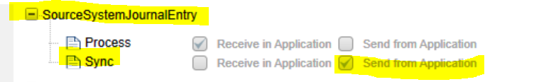

Sync.SourceSystemGeneralEntry
Sync.CustomerPartyMaster
Sync.RemitToPartyMaster
Sync.SupplierPartyMaster
Sync.LnMessage
Sync.RFQ
Sync.Invoice
Sync.Contract
Sync.SupplierInvoice
Sync.PayableTransaction
Sync.ProjectContractDeliverable
Sync.ProjectBudget

Infor ION-Process Components

4.1 Monitors
Import the Attached Monitors into ION.

Import Monitors from location <UnZip>\ Monitors
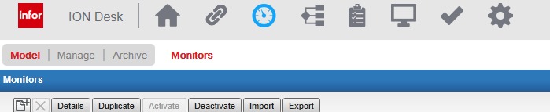

->Select “Import”
-> Select .xml file from folder Unzip <Deliverables.zip>\ Monitors
-> When same monitor exists in ION prompts for action to be selected
Note: - Go to distribution tab of monitor and change the distribution users as per alert requirement

4.2 Email Template Upload

Upload email template .zip from location <UnZip>\ Email_Template

-> On E-mail Templates group select “Upload Updated Set of Templates” button
-> Select the .zip file under <UnZip>\ Email_Template

