

Custom BODs
Delivery Document

Document information

Author | Sattiraju Namala
Document ID | CUSTF001
Document Version | 0.1
Document Title | Custom BODs
Document Platform | Infor® ERP LN Fp9
Document Reference
Status | Draft In Review Approved

Change Control
Version | Date | Status | Reviewer | Changes
0.1 | 03/06/2014 | Initial |  | New

Term | Description
ERP | Enterprise Resource Planning
ION | Integrated Open Network, SOA integration platform used by Infor
BOD | Business Object Definition
XML | Extended Mark-up Language
WH | Infor® ERP_{LN} Warehousing Package
TC | Infor® ERP_{LN} Common Package
LCT | Infor® ERP_{LN} Landed Costs
CMG | Infor® ERP_{LN} Cash Management
PPC | Infor® ERP_{LN} Project production Control
CTM | Infor® ERP_{LN} Contract Module
ACP | Infor® ERP_{LN} Accounts Payable
INA | Infor® ERP_{LN} Inventory Analysis
RRP | Infor® ERP_{LN} Resource Requirement planning
CCP | Infor® ERP_{LN} Central calendar Management
PPL | Infor® ERP_{LN} People
FAM | Infor® ERP_{LN} Fixed Assets Management
BAES | Infor® ERP_{LN} BAES Customization Package

Content
1 Introduction 5
2 Infor ERP LN Components 6
2.1 PMC 6
2.2 New or modified Server components 6
3 Infor ION-Connect Components 9
4 Infor ION-Process Components 10

Introduction

The Solution contains the components for the below custom BOD requirment.

CB001-LandedCosts_BAES
CB002-AnticipatedPaymentsReceiptsDetails_BAES
CB003-Revenues_BAES
CB004-BankGuarantees_BAES
CB006-RemittanceAdvice_BAES
CB007-LNMessage
CB008-OneTimeSupplierAddress_BAES
CB009-MAUC_BAES
CB010-MAUCDetails_BAES
CB018-ResourcePlanning_BAES
CB019-CalendarTimeInterval_BAES
CB020-SkillsByEmployee_BAES
CB021-LaborCostHistory_BAES
CB023-AgingAnalysis_BAES
CB030-AssetBook_BAES

Infor ERP LN Components

PMC
PMC | Description | Dependencies
CUSTF001 | Custom BODs | NA

New or modified Server components
Component Type | Component | Description | New/Modified | Dump Path
Business Object | Bolct901 | Landed Costs_BAES | New
Business Object | Bocmg904 | Anticipated Pay rec Details_BAES | New
Business object | Boppc901 | Revenues_BAES | New
Business object | Boctm901 | Bank Guarentee_BAES | New
Business object | Bocmg903 | Remittance Advice_BAES | New
Business object | Boacp901 | One Time Supplier Address_BAES | New
Business object | Boina901 | MAUC_BAES | New
Business object | Boina902 | MAUCDetails_BAES | New
Business object | Borrp901 | Resource Planning_BAES | New
Business object | Boccp901 | Calendar Time interval_BAES | New
Business object | Boppl902 | Skills By Employee_BAES | New
Business object | Boppc902 | Labor Cost History_BAES | New
Business object | Boacp902 | Aging Analysis_BAES | New
Business object | Bofam906 | Asset Book_BAES | New
Component Type | Component | Description | New/Modified | Dump Path
Label | Bolct901 | Landed Costs_BAES | New
Label | Bocmg904 | Anticipated Pay rec Details_BAES | New
Label | Boppc901 | Revenues_BAES | New
Label | Boctm901 | Bank Guarentee_BAES | New
Label | Bocmg903 | Remittance Advice_BAES | New
Label | Boacp901 | One Time Supplier Address_BAES | New
Label | Boina901 | MAUC_BAES | New
Label | Boina902 | MAUCDetails_BAES | New
Label | Borrp901 | Resource Planning_BAES | New
Label | Boccp901 | Calendar Time interval_BAES | New
Label | Boppl902 | Skills By Employee_BAES | New
Label | Boppc902 | Labor Cost History_BAES | New
Label | Boacp902 | Aging Analysis_BAES | New
Label | Bofam906 | Asset Book_BAES | New

Notes: Convert to runtime has to be done for all the labels.

Component Type | Component | Description | New/Modified | Dump Path
Library | Tclct200ue | UE for Landed Cost Lines | New
Library | Tfcmg111ue | Anticipated Payments_BAESBOD | New
Library | Tpppc301ue | SyncRevenues_BAESBOD | New
Library | Tpctm020ue | BankGuarentee_BAESBOD | New
Library | Tfcmg250ue | BOD Remittance Advice Details | New
Library | Tfcmg251ue | BOD Remittance Advice Line Details | New
Library | Tfacp202ue | User exit DLL for one time supplier address | New
Library | Whina134ue | UE for MAUC by Item and warehouse valuation group | New
Library | Whina135ue | User exit DLL for MAUC by warehouse valuation group | New
Library | Cprrp200ue | Resource Planning-BAES | New
Library | Tcccp020ue | User exit DLL for calendar Working Times | New
Library | Tcppl020ue | SkillsByEmployee_BAES | New
Library | Tpppc200ue | UE for Labour Cost History | New
Library | Tfacp004ue | AgingAnalysis_BAES | New
Library | Tfacpdllc001 | Support dll for Aging analysis BOD | New
Library | Tffam110ue | UE for Asset Book DAL(tffam110) | New
Library | Tfacp001ue | Financial Supplier Groups | New
Library | Tfacp002ue | Hold Reason Codes | New

Note : One the Solution is installed on ERPLN server register the following BODs in Bod Implementation Registration session(bobod100m000) in respective companies.
Bolct901 | Landed Costs_BAES
Bocmg904 | Anticipated Pay rec Details_BAES
Boppc901 | Revenues_BAES
Boctm901 | Bank Guarentee_BAES
Bocmg903 | Remittance Advice_BAES
Boacp901 | One Time Supplier Address_BAES
Boina901 | MAUC_BAES
Boina902 | MAUCDetails_BAES
Borrp901 | Resource Planning_BAES
Boccp901 | Calendar Time interval_BAES
Boppl902 | Skills By Employee_BAES
Boppc902 | Labor Cost History_BAES
Boacp902 | Aging Analysis_BAES
Bofam906 | Asset Book_BAES

Infor ION-Connect Components
3.1) The following BODs needs to be registered in ION.
3.1.1) unzip the Developer.zip file and copy the content to <ION_Installed_Folder>\Desk\bin\RegistryData\BodMetaData\Custom\BODs\Developer folder
3.1.2) Unzip the Nouns.zip file and copy the Content Info <ION_Installed_Folder>\Desk\bin\RegistryData\BodMetaData\Custom\Resources\Nouns folder
3.1.3) Unzip the XML.zip file and copy the content into <ION_Installed_Folder>\Desk\bin\RegistryData\BodMetaData\Custom\XML folder
3.2) Modify the ERPLN connection point and add the following Documents as ‚Sync can be send from Application‘

LandedCosts_BAES
AnticipatedPayRecDetails_BAES
Revenues_BAES
BankGuarentee_BAES
RemittanceAdvice_BAES
OneTimeSupplierAddress_BAES
MAUC_BAES
MAUCDetails_BAES
ResourcePlanning_BAES
CalendarTimeInterval_BAES
SkillsByEmployee_BAES
LaborCostHistory_BAES
AgingAnalysis_BAES
AssetBook_BAES

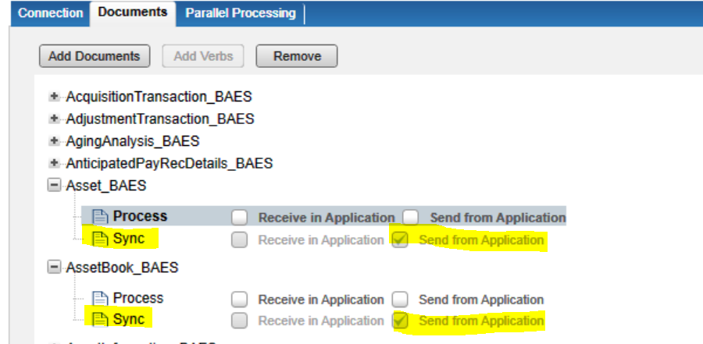

3.3) Configure these documents into Business vault connection as Sync can be Received by Application.
3.4) Create the Document flow from ERPLN into Business Vault and activate the document flow.

Infor ION-Process Components
N.A

