




Project Phoenix
CUSTF039 – TaxReporting_BAESBOD

Document Information
Author(s) | Sattiraju Namala
Version | 1.0
Customer | BAE Systems
Project | Phoenix
Phase | Testing
Status |  Initial  Follow-up

Change Control
Version | Editor | Date | Changes
1.0 | Sattiraju Namala | 29-SEP-2015 | Document Created

Table of Contents

1 Document Information 2
1.1 Change Control 2
3 Glossary 4
4 Introduction 5
4.1 Test scenarios 5
4.2 Test Results 5
4.2.1 TEST CASE- TC-01 5
4.2.2 TEST CASE- TC-02 8
4.2.3 TEST CASE- TC-03 13
4.2.4 TEST CASE- TC-04 13

Glossary
Term | Description

Introduction

Test scenarios
Test Case | Description of flow | Values to be validated in BOD | Expected result
TC-01 | Create Purchase Invoice forPublishing TaxReport_BAESBOD | Values sent from LN to bod xml | TaxReporting_BAESBOD created with 4 Purchase Order Lines
TC-02 | Create Invoice with Revenue Details to test Revenue Lines | Values sent from LN to bod xml | TaxReporting_BAESBOD created with Revenue Details

Test Results

TEST CASE- TC-01

Create Purchase Invoice for Publishing TaxReport_BAESBOD.
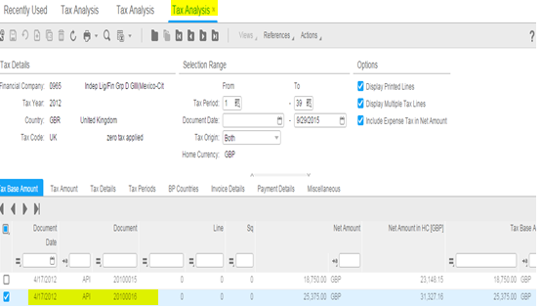

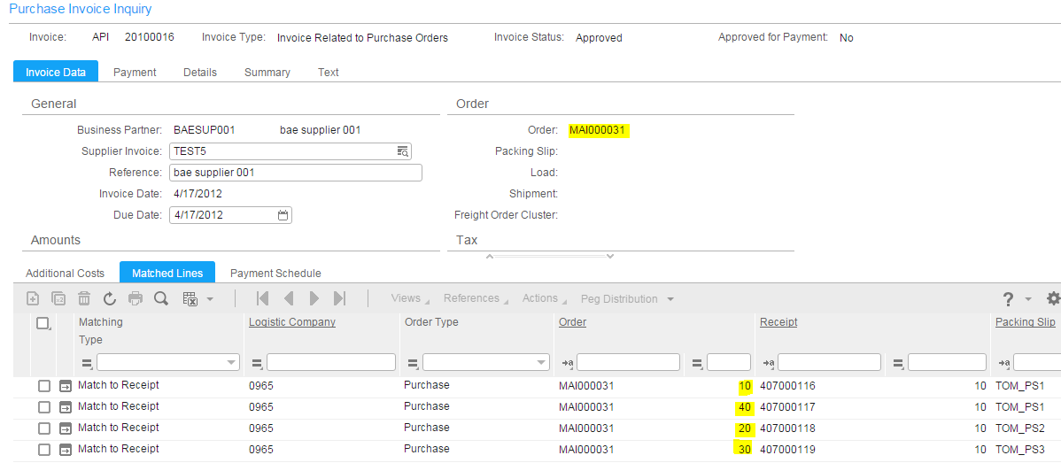

Output:
<SyncTaxReporting_BAES
xmlns="http://schema.infor.com/InforOAGIS/2"
xmlns:xsi="http://www.w3.org/2001/XMLSchema-instance"
xsi:schemaLocation="http://schema.infor.com/2.2.0/InforOAGIS http://schema.infor.com/2.2.0/InforOAGIS/BODs/Developer/SyncTaxReporting_BAES.xsd"
xmlns:xsd="http://www.w3.org/2001/XMLSchema"
releaseID="2">
<ApplicationArea>
<Sender>
<LogicalID>lid://infor.ln.erpln_bae_104_fp10</LogicalID>
<ComponentID>erp</ComponentID>
<ConfirmationCode>OnError</ConfirmationCode>
</Sender>
<CreationDateTime>2015-09-29T06:59:09Z</CreationDateTime>
<BODID>infor-nid:infor:965:S_965:965_API_20100016_0_0_0:?TaxReporting_BAES&amp;verb=Sync</BODID>
</ApplicationArea>
<DataArea>
<Sync>
<TenantID>infor</TenantID>
<AccountingEntityID>965</AccountingEntityID>
<LocationID>S_965</LocationID>
<ActionCriteria>
<ActionExpression
actionCode="Replace"
/>
</ActionCriteria>
</Sync>
<TaxReporting_BAES>
<DocumentID>
<ID
accountingEntity="965"
location="S_965"
variationID=""
lid="lid://infor.ln.erpln_bae_104_fp10">965_API_20100016_0_0_0</ID>
</DocumentID>
<BusinessPartnerNumber>BAESUP001</BusinessPartnerNumber>
<BusinessPartnerName>bae supplier 001</BusinessPartnerName>
<BusinessPartnerVerificationNumber></BusinessPartnerVerificationNumber>
<SupplierInvoiceNumber>TEST5</SupplierInvoiceNumber>
<LNInvoiceNumber>API20100016</LNInvoiceNumber>
<InvoiceDate>2012-04-17</InvoiceDate>
<Currency>GBP</Currency>
<GrossValueOfInvoiceBI094>31327.16</GrossValueOfInvoiceBI094>
<WithHoldingTaxDeductedBI094>0</WithHoldingTaxDeductedBI094>
<KindOfTax>vat</KindOfTax>
<TaxClassification></TaxClassification>
<TaxPeriod>16</TaxPeriod>
<TaxYear>2012</TaxYear>
<BAESystemsVATRegistrationNumberBI97>123XYZ</BAESystemsVATRegistrationNumberBI97>
<TaxBusinessPartner>BAESUP001</TaxBusinessPartner>
<ReportingPeriod>16</ReportingPeriod>
<FiscalYear>2012</FiscalYear>
<FiscalPeriod>16</FiscalPeriod>
<BusinessPartnerVATNumber></BusinessPartnerVATNumber>
<InvoiceValueCurrencyNETBI096>25375</InvoiceValueCurrencyNETBI096>
<InvoiceValueCurrencyVATBI096>0</InvoiceValueCurrencyVATBI096>
<TaxPointDateACROpenItems></TaxPointDateACROpenItems>
<TaxCode>UK</TaxCode>
<TaxOrigin>in</TaxOrigin>
<BusinessPartnerCountryCode></BusinessPartnerCountryCode>
<InvoiceValueInESLSubmissionCurrency>31327.16</InvoiceValueInESLSubmissionCurrency>
<TaxPointDateContractInstallments></TaxPointDateContractInstallments>
<BAESystemsVATCountry>GBR</BAESystemsVATCountry>
<BusinessPartnerNumberACP>BAESUP001</BusinessPartnerNumberACP>
<BusinessPartnerNameACP>bae supplier 001</BusinessPartnerNameACP>
<InvoiceDate2>2012-04-17</InvoiceDate2>
<TaxcodePurchaseInvoice>UK</TaxcodePurchaseInvoice>
<InvoiceValueInCurrencyGrossACP>25375</InvoiceValueInCurrencyGrossACP>
<InvoiceValueInCurrencyVATACP>0</InvoiceValueInCurrencyVATACP>
<PurchaseOrder>
<ID>MAI000031</ID>
<PurchaseOrderLine>
<LineNumber>10</LineNumber>
<ExtendedAmount>125</ExtendedAmount>
<TaxCodePerPo>UK</TaxCodePerPo>
<TaxCountryCodePerPO>GB</TaxCountryCodePerPO>
</PurchaseOrderLine>
<PurchaseOrderLine>
<LineNumber>20</LineNumber>
<ExtendedAmount>125</ExtendedAmount>
<TaxCodePerPo>UK</TaxCodePerPo>
<TaxCountryCodePerPO>GB</TaxCountryCodePerPO>
</PurchaseOrderLine>
<PurchaseOrderLine>
<LineNumber>30</LineNumber>
<ExtendedAmount>125</ExtendedAmount>
<TaxCodePerPo>UK</TaxCodePerPo>
<TaxCountryCodePerPO>GB</TaxCountryCodePerPO>
</PurchaseOrderLine>
<PurchaseOrderLine>
<LineNumber>40</LineNumber>
<ExtendedAmount>25000</ExtendedAmount>
<TaxCodePerPo>UK</TaxCodePerPo>
<TaxCountryCodePerPO>GB</TaxCountryCodePerPO>
</PurchaseOrderLine>
</PurchaseOrder>
<DateOfDelivery></DateOfDelivery>
<NetAmount
currencyID="GBP">31327.16</NetAmount>
<NetAmount
currencyID="EUR">36715.23</NetAmount>
<NetAmount
currencyID="USD">36250</NetAmount>
<TaxBaseAmount
currencyID="GBP">31327.16</TaxBaseAmount>
<TaxBaseAmount
currencyID="EUR">36715.23</TaxBaseAmount>
<TaxBaseAmount
currencyID="USD">36250</TaxBaseAmount>
<TaxAmount
currencyID="GBP">0</TaxAmount>
<TaxAmount
currencyID="EUR">0</TaxAmount>
<TaxAmount
currencyID="USD">0</TaxAmount>
<TaxScenario>Not Applicable</TaxScenario>
<InvoiceCurrency>GBP</InvoiceCurrency>
</TaxReporting_BAES>
</DataArea>
</SyncTaxReporting_BAES>
Result: Pass

TEST CASE- TC-02
Create Invoice with Revenue Details to test Revenue Lines
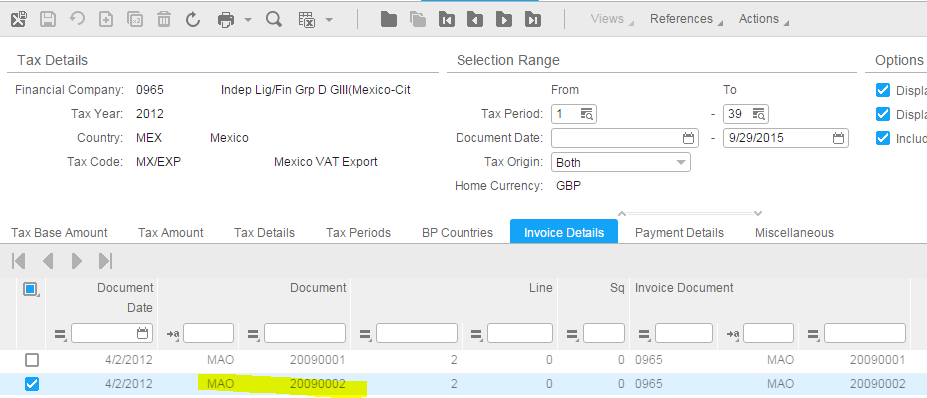
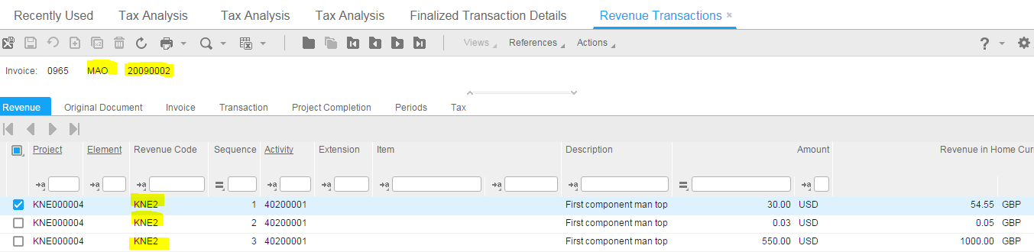
Output:
<SyncTaxReporting_BAES
xmlns="http://schema.infor.com/InforOAGIS/2"
xmlns:xsi="http://www.w3.org/2001/XMLSchema-instance"
xsi:schemaLocation="http://schema.infor.com/2.2.0/InforOAGIS http://schema.infor.com/2.2.0/InforOAGIS/BODs/Developer/SyncTaxReporting_BAES.xsd"
xmlns:xsd="http://www.w3.org/2001/XMLSchema"
releaseID="2">
<ApplicationArea>
<Sender>
<LogicalID>lid://infor.ln.erpln_bae_104_fp10</LogicalID>
<ComponentID>erp</ComponentID>
<ConfirmationCode>OnError</ConfirmationCode>
</Sender>
<CreationDateTime>2015-09-29T06:59:15Z</CreationDateTime>
<BODID>infor-nid:infor:965:S_965:965_MAO_20090002_2_0_0:?TaxReporting_BAES&amp;verb=Sync</BODID>
</ApplicationArea>
<DataArea>
<Sync>
<TenantID>infor</TenantID>
<AccountingEntityID>965</AccountingEntityID>
<LocationID>S_965</LocationID>
<ActionCriteria>
<ActionExpression
actionCode="Replace"
/>
</ActionCriteria>
</Sync>
<TaxReporting_BAES>
<DocumentID>
<ID
accountingEntity="965"
location="S_965"
variationID=""
lid="lid://infor.ln.erpln_bae_104_fp10">965_MAO_20090002_2_0_0</ID>
</DocumentID>
<BusinessPartnerNumber>BPG000002</BusinessPartnerNumber>
<BusinessPartnerName>Mathijs</BusinessPartnerName>
<BusinessPartnerVerificationNumber></BusinessPartnerVerificationNumber>
<SupplierInvoiceNumber></SupplierInvoiceNumber>
<LNInvoiceNumber>MAO20090002</LNInvoiceNumber>
<InvoiceDate>2012-04-02</InvoiceDate>
<Currency>USD</Currency>
<GrossValueOfInvoiceBI094>0</GrossValueOfInvoiceBI094>
<WithHoldingTaxDeductedBI094>0</WithHoldingTaxDeductedBI094>
<KindOfTax>vat</KindOfTax>
<TaxClassification></TaxClassification>
<TaxPeriod>13</TaxPeriod>
<TaxYear>2012</TaxYear>
<BAESystemsVATRegistrationNumberBI97></BAESystemsVATRegistrationNumberBI97>
<TaxBusinessPartner></TaxBusinessPartner>
<ReportingPeriod>13</ReportingPeriod>
<FiscalYear>2012</FiscalYear>
<FiscalPeriod>13</FiscalPeriod>
<BusinessPartnerVATNumber></BusinessPartnerVATNumber>
<InvoiceValueCurrencyNETBI096>-580.03</InvoiceValueCurrencyNETBI096>
<InvoiceValueCurrencyVATBI096>0</InvoiceValueCurrencyVATBI096>
<TaxPointDateACROpenItems></TaxPointDateACROpenItems>
<TaxCode>MX/EXP</TaxCode>
<TaxOrigin>out</TaxOrigin>
<BusinessPartnerCountryCode>NLD</BusinessPartnerCountryCode>
<InvoiceValueInESLSubmissionCurrency>-1054.6</InvoiceValueInESLSubmissionCurrency>
<TaxPointDateContractInstallments></TaxPointDateContractInstallments>
<BAESystemsVATCountry></BAESystemsVATCountry>
<BusinessPartnerNumberACP></BusinessPartnerNumberACP>
<BusinessPartnerNameACP></BusinessPartnerNameACP>
<InvoiceDate2></InvoiceDate2>
<TaxcodePurchaseInvoice></TaxcodePurchaseInvoice>
<InvoiceValueInCurrencyGrossACP>0</InvoiceValueInCurrencyGrossACP>
<InvoiceValueInCurrencyVATACP>0</InvoiceValueInCurrencyVATACP>
<PurchaseOrder>
<ID></ID>
</PurchaseOrder>
<DateOfDelivery></DateOfDelivery>
<NetAmount
currencyID="GBP">-1054.6</NetAmount>
<NetAmount
currencyID="EUR">-462.15</NetAmount>
<NetAmount
currencyID="USD">-580.03</NetAmount>
<TaxBaseAmount
currencyID="GBP">-1054.6</TaxBaseAmount>
<TaxBaseAmount
currencyID="EUR">-462.15</TaxBaseAmount>
<TaxBaseAmount
currencyID="USD">-580.03</TaxBaseAmount>
<TaxAmount
currencyID="GBP">0</TaxAmount>
<TaxAmount
currencyID="EUR">0</TaxAmount>
<TaxAmount
currencyID="USD">0</TaxAmount>
<TaxScenario>Not Applicable</TaxScenario>
<InvoiceCurrency></InvoiceCurrency>
<ProjectRevenue>
<RevenueCode>KNE2</RevenueCode>
<FinancialTransactionType>MAO</FinancialTransactionType>
<FinancialDocumentNumber>20090002</FinancialDocumentNumber>
</ProjectRevenue>
</TaxReporting_BAES>
</DataArea>
</SyncTaxReporting_BAES>
Result: Pass

