ION Custom Components and Metadata Deployment Instructions
Important: This document is intended for user(s) who have Infor ION 11.x & its registry knowledge.

Backup Existing ION Components
- Back up existing document flow in the targeted ION by exporting them with connection points before importing document flows

Export Document Flows:
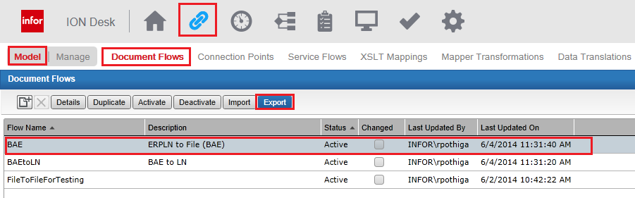

Select Connection Points:
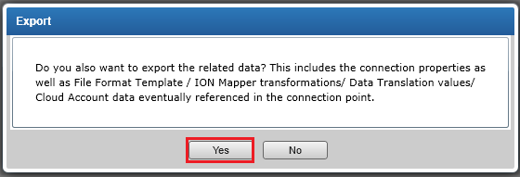

- Back up existing workflows, activation polices and Monitors (Alerts) by exporting them

Export Workflows:
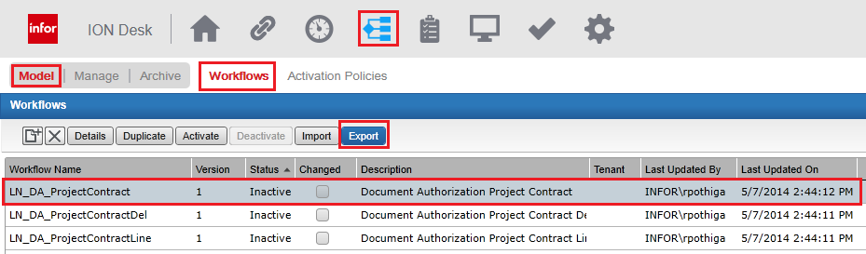

Export Activation Policies:
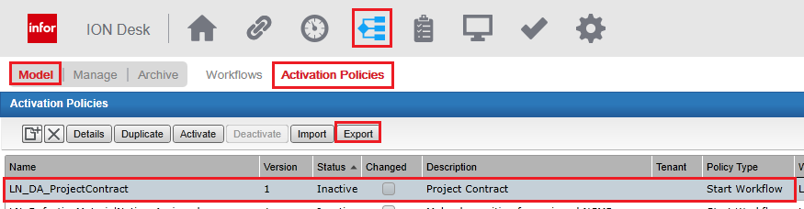

Export Monitors:
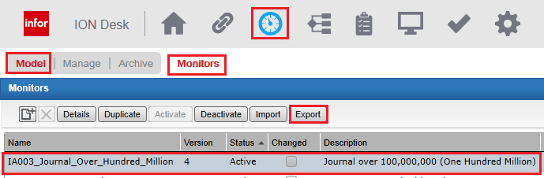

- Back up ION Custom BOD’s folder.
Folder path <ION Install Rootpath>\ION\Desk\bin\RegistryData\BodMetaData\Custom

Back-up Custom Folder:
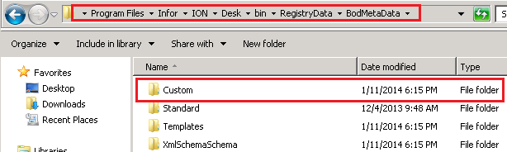

ION Deliverable Details
Unzip the CR228F001_ION.zip file supplied along with this delivery into a folder of your choice.
Contents of CR228F001_ION.zip
- “Custom” folder – the contents of this folder vary depending on the type of customization developed. This folder holds custom BOD’s developed and is a mirror of the ION registry folder structure.
  - It contains custom noun XSD’s under folder “Custom\Resources\Nouns”
  - It contains BOD XSD for above custom nouns under folder “Custom\BODs\Developer”
  - It contains custom noun id path and relation XML’s under folder “Custom\XML”
- “DocumentFlows” Folder – the content availability depends on the type of customization developed. This folder holds Document Flows developed.
- “Workflows” Folder – the content availability depends on the type of customization developed. This folder holds Workflows developed.
- “ActivationPolicies” Folder – the content availability depends on the type of customization developed. This folder holds Activation Polices required for above mentioned workflows developed.
- “Monitors” Folder – the content availability depends on the type of customization developed. This folder holds Workflows developed.
- “EmailTemplates” – the content availability depends on the type customization developed. This folder holds Email Templates for Workflows and Alerts
- ConnectionPoints – where there is a need to delivery connection points separately these shall be available under this folder. This folder may further XSLT_Mappings and/or ION_Mapper subfolders depending on the customization.

Custom BOD’s Deployment (ION Registry Changes)
Ensure copying of file does not overwrite existing files unless you are repeating your copy action, overwrite could lead to corrupt your existing (previous) customization

BOD Deployment
  - Copy all .xsd files from location <UnZip Location>\Custom\BODs\Developer to <ION Install Rootpath>\ION\Desk\bin\RegistryData\BodMetaData\Custom\BODs\Developer

Noun Deployment
  - Copy all .xsd files from location <UnZip Location >\Custom\Resources\Nouns to <ION Install Rootpath>\ION\Desk\bin\RegistryData\BodMetaData\Custom\Resources\Nouns

XML Deployment

NounIDsInstance Deployment
    - Copy all .XML files from location <UnZip Location >\Custom\Resources\XML to <ION Install Rootpath>\ION\Desk\bin\RegistryData\BodMetaData\Custom\XML

NounUserAreaMetadata Deployment (if applicable)
If this interface uses a custom XML structure under <BODNOUN>/UserArea this process is required. If the XML elements in this custom XML structure are being referred to in one or more of the following, it is essential to register the schema for the custom XML structure in ION Registry.
- If you want to select your properties in ION Connect, in content- based routing or filtering.
- If you want to select your properties in ION Process, in an event monitor or an activation policy.
IMPORTANT: The process to change ION registry for adding custom XML in UserArea is outlined in detail in the “Infor ION Technical Reference Guide” for ION version 11.x. Please refer to it in parallel while carrying out the following instructions.
- The XSD to be placed in ION registry is provided along with this delivery. Unzip this into a folder. The XSD schema file is named as “<FileName>.xsd” and is present under the folder structure “Custom\UserAreaExtensions\BAE”.
- Go to the following folder
<IONInstallation Folder>\Desk\bin\RegistryData\BodMetaData\Custom\XML
- Open the file with the following name in edit mode
NounUserAreaMetadata.xml
- Ensure that the following line is present at the top-
<UserAreaMetadata customizer="BAE">
- Add the following under the <UserAreaMetadata> XML element.
<RelatedNoun name="<NounName>">
<UserArea>
<XPath><Full Path to UserArea from Noun></XPath>
<XMLSchema><FileName>.xsd</XMLSchema>
</UserArea>
</RelatedNoun>

Import ION Document Flows (if applicable)
  - Import document flows from location <UnZip>\ Document_Flows

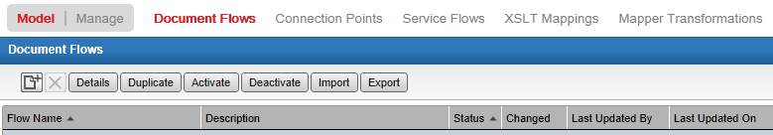

Select “Import”
Select .xml file from folder DocumentFlows
When same document flow exists in ION prompts for what action to be done, select option to appropriate
After Import completed correct the connection settings (Example: ERPLN connection details, Database connection details and store procedures, for more details refer below connection section)
Note: - ION Document Flows are always exported with Connection points and Mappings unless there is need to delivery separate or delivery is a patch

Import Workflows (if applicable)
  - Import workflow from location <UnZip>\ Process_Templates\Work_Flow_Templates
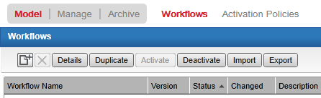

Select “Import”
Select .xml file from folder WorkFlows
When same Workflow exists in ION prompts for action to be done
5.2 Import Activation Policies from ActivationPolicies folder
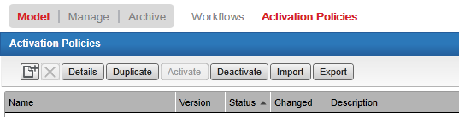

->Select “Import”
-> Select .xml file from folder <UnZip>\ Process_Templates\Activation_Polices
-> When same workflow exists in ION prompts for action to be selected
Note: - Go to distribution tab of task and notification and change the distribution users as per process flow requirement

Import Monitors (if applicable)
  - Import workflow from location <UnZip>\ Monitors

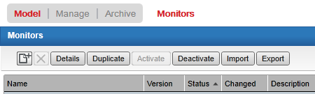

->Select “Import”
-> Select .xml file from folder Monitors
-> When same monitor exists in ION prompts for action to be selected
Note: - Go to distribution tab of monitor and change the distribution users as per alert requirement

Email Template Upload (if applicable)
  - Upload email template .zip from location EmailTemplates

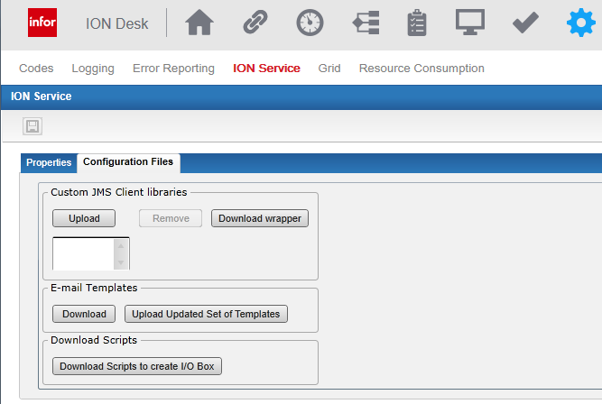

-> On E-mail Templates group select “Upload Updated Set of Templates” button
-> Select the .zip file under EmailTemplates folder

Importing Connection points (if applicable)
When there is need to deliver connection points separately those are available under folder ConnectionPoints, further connection points are categorized based on connective type
  - XSLT Mapping
Import XSLT Mappings from folder ConnectionPoints\XSLT_Mapping
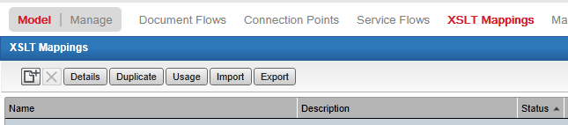

Click “Import” on XSLT Mapping and select the XSLT mapping xml from “XSLT_Mapping” folder

  - ION Mapper
Import ION Mapper, if present, from folder ConnectionPoints \ ION_Mapper
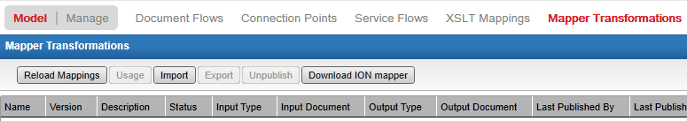

  - Other Connections
Import connection points, if present, from folder ConnectionPoints

ERPLN Connection Point
Verify ERPLN connection settings after import and adjust as required. Typically you would need to change the connection information in the “Connections” tab and select the relevant BODs in the “Documents” tab. Following screenshots provide a quick walkthrough.
Note: - Data present in screen shots are from development environment and are for indicative purposes only. They may be different from the target ION system where this delivery is being configured.

Screen Shots
Connection Tab:
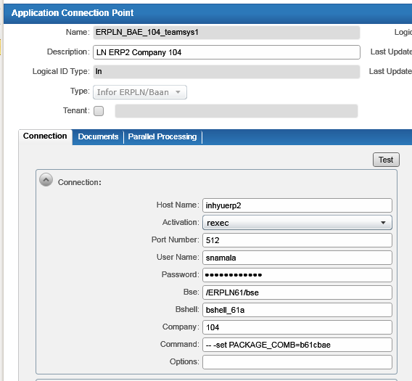
Change the connection properties as per the target system.
Click on “Test” and verify that ION responds with a success message.
Documents Tab:
Add the newly registered custom BODs and configure the send/receive properties appropriately.
