Incident - 5012569

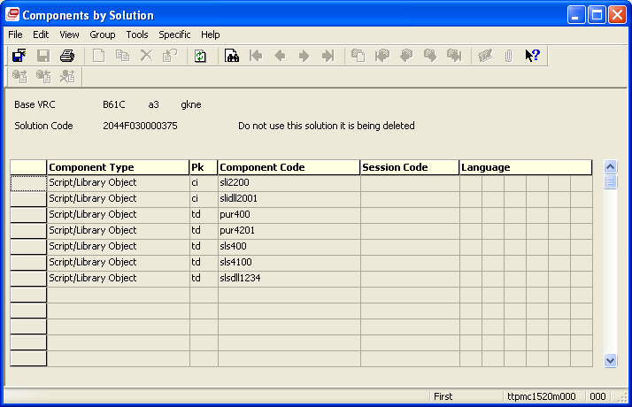

This solution was deleted as GKN decided not to install the std solution.
All traces of this should have been deleted at GKN.
Re-engineering was backed out at Infor and the solution status re-set

